**SQL Server**

**SQL**

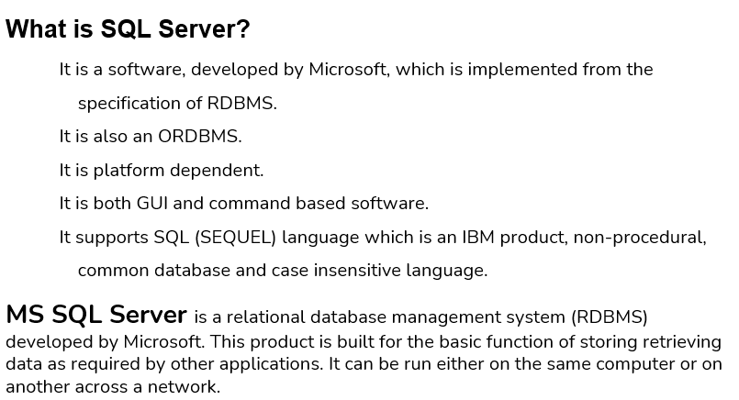

**Create Alter and Delete Database**

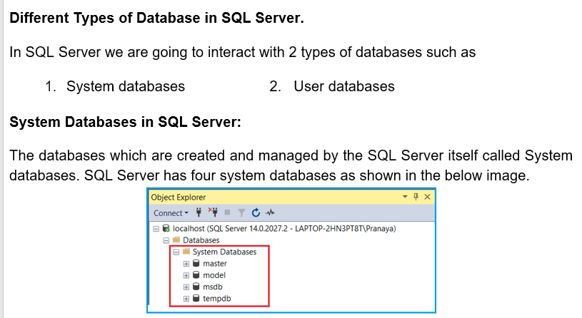

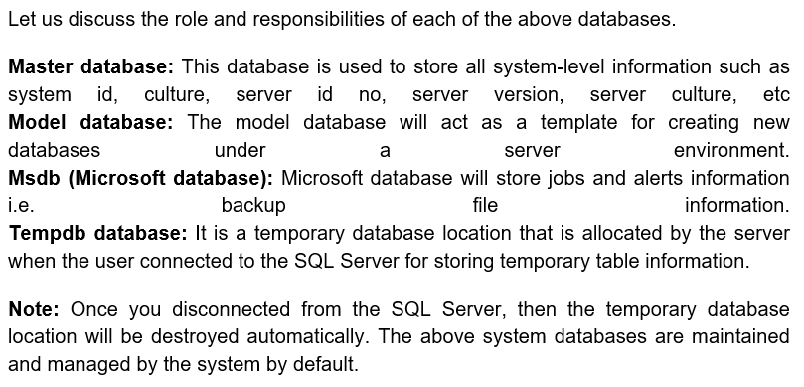

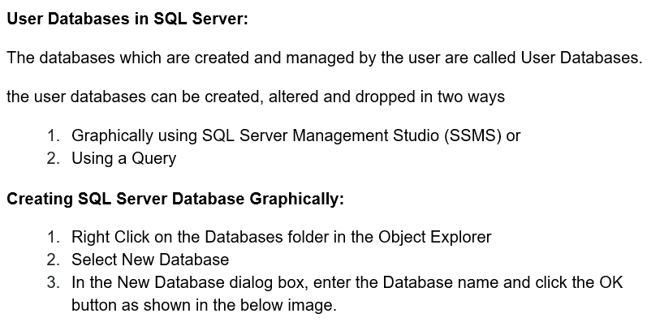

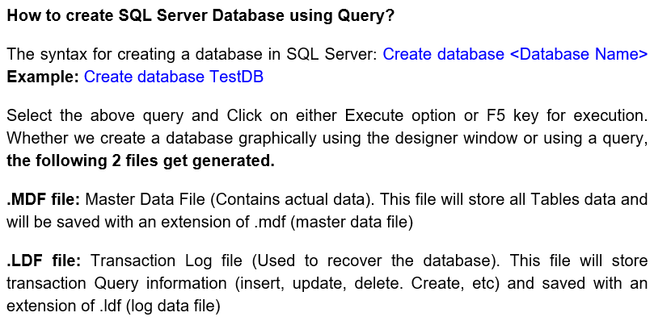

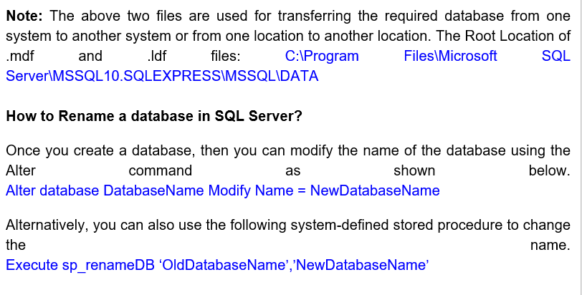

**Example**

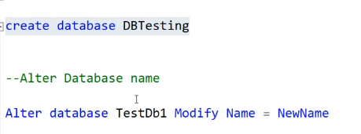

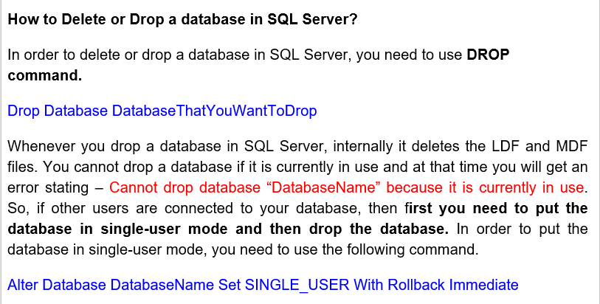

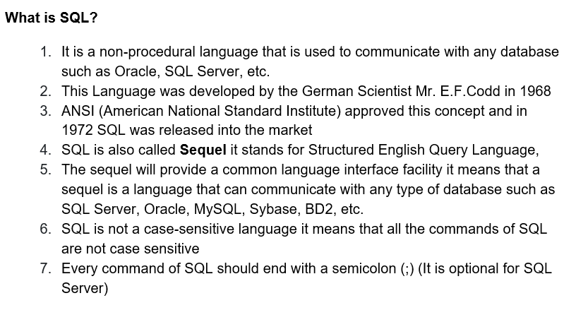

**SQL Data Types in SQL Server**

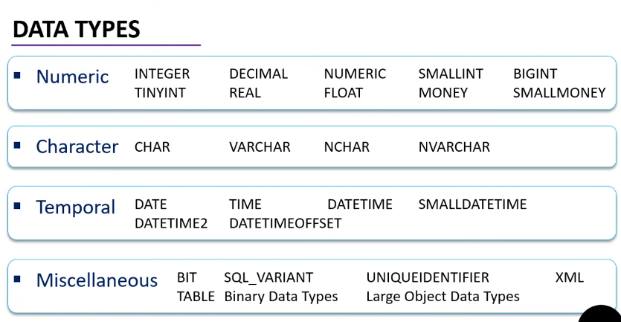

**Integrity Constraints**

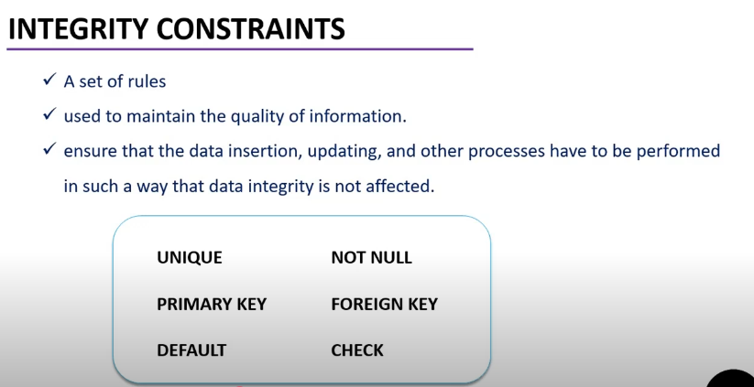

**Primary Key and Foreign Key in SQL Server**

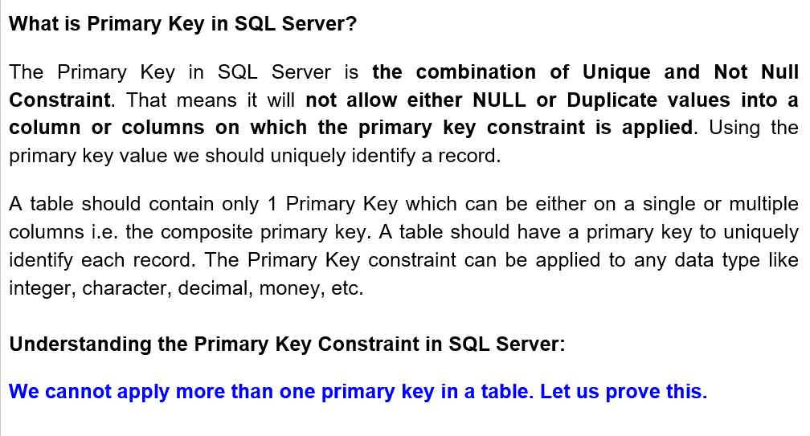

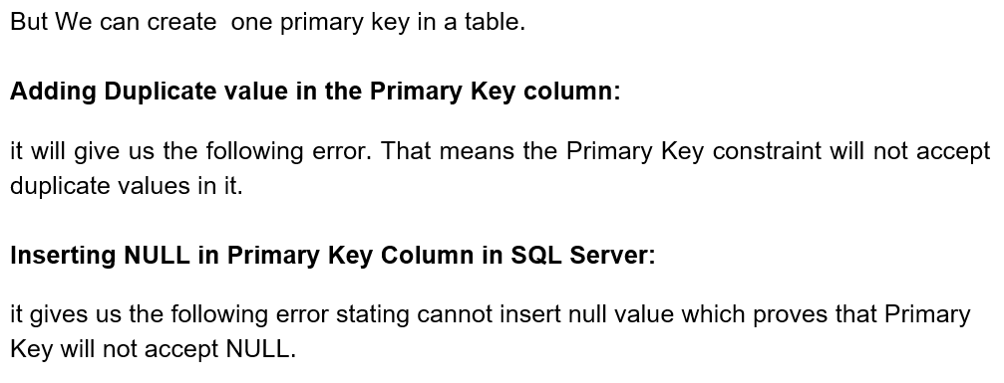

**Example:**

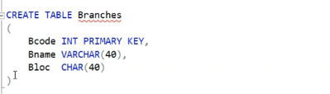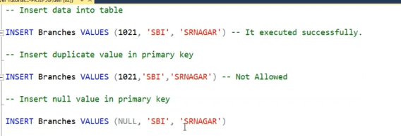

**Composite Primary Key**

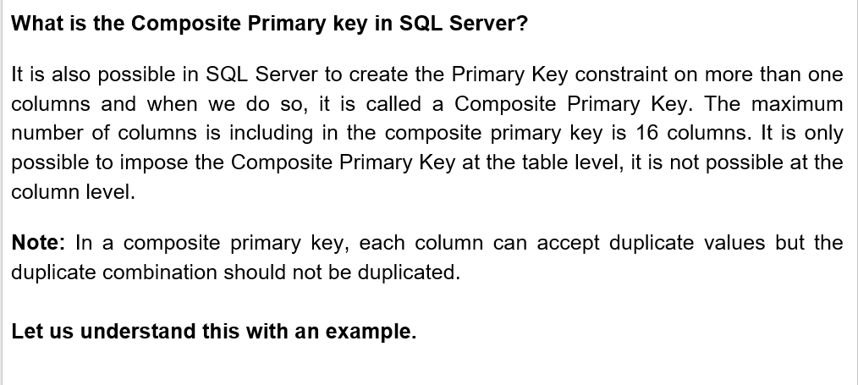

**Example:**

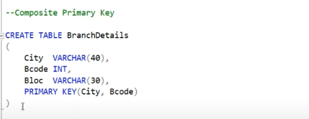

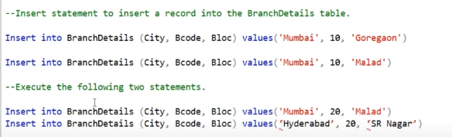

**Foreign key**

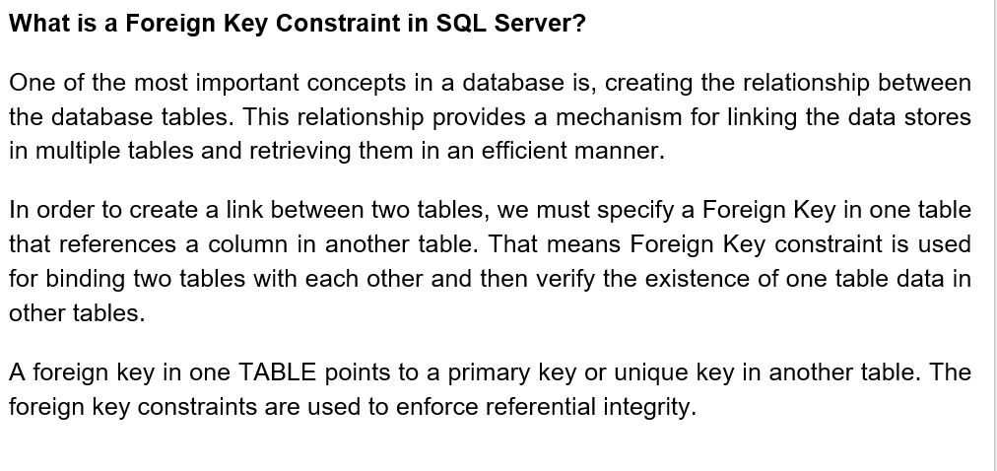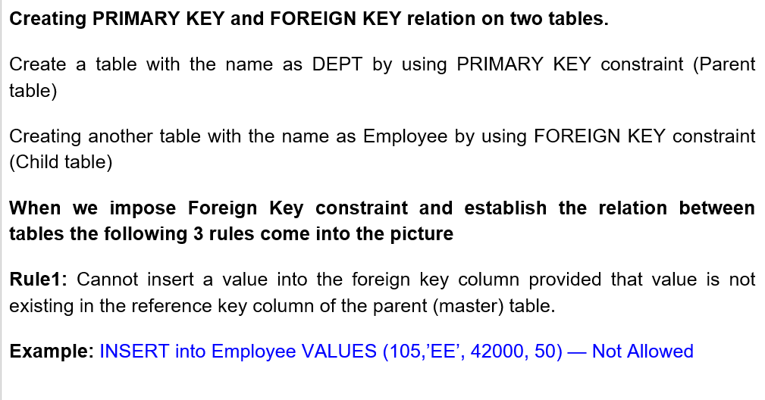

**Example:**

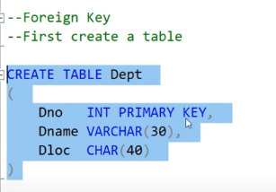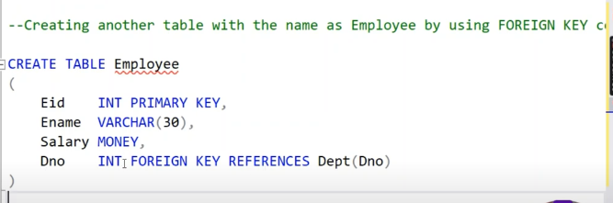

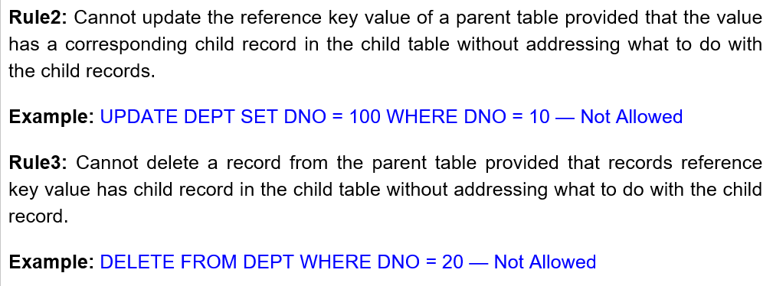

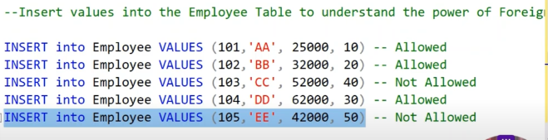

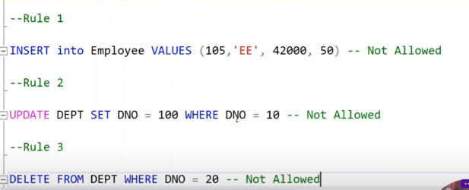

**SQL Statements – INTRO**

**DDL – Data Definition Language**

**DML- Data Manipulation Language**

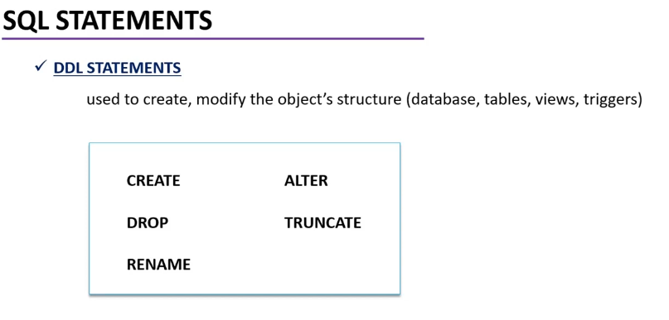

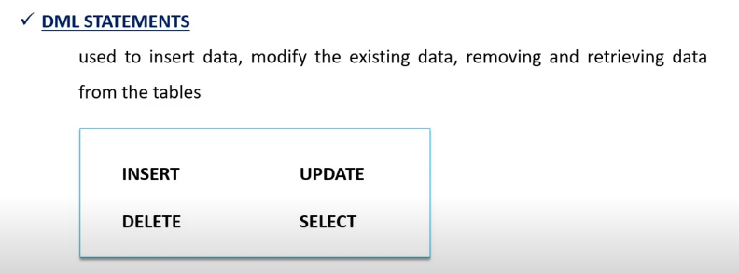

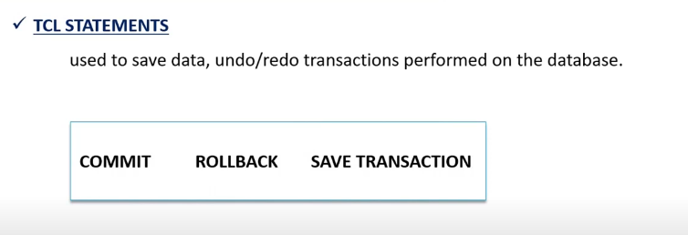

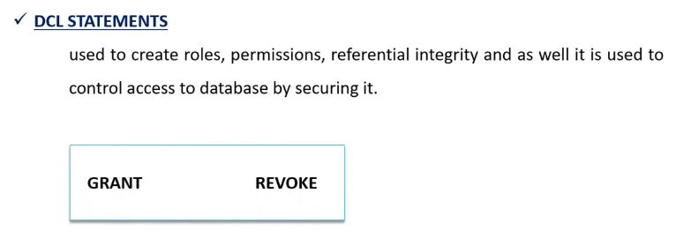

**CREATE Statement**

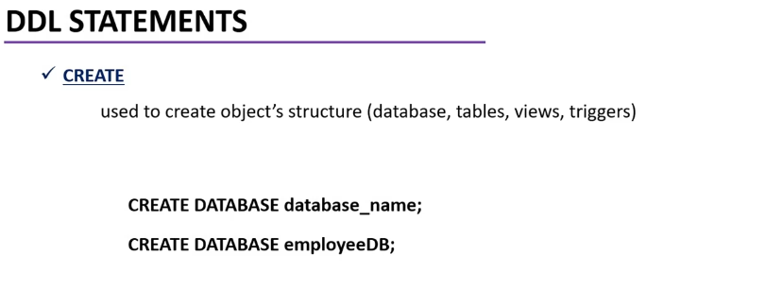

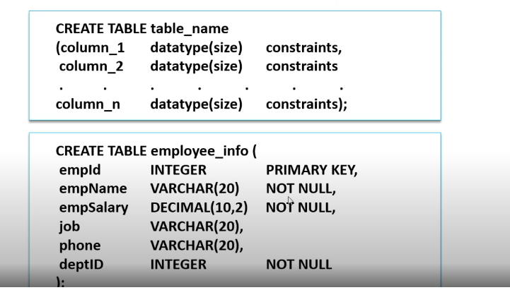

**INSERT STATEMENT**

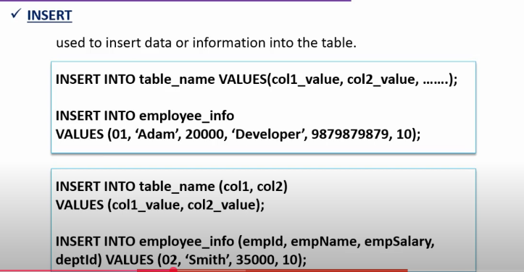

**SELECT STATEMENT**

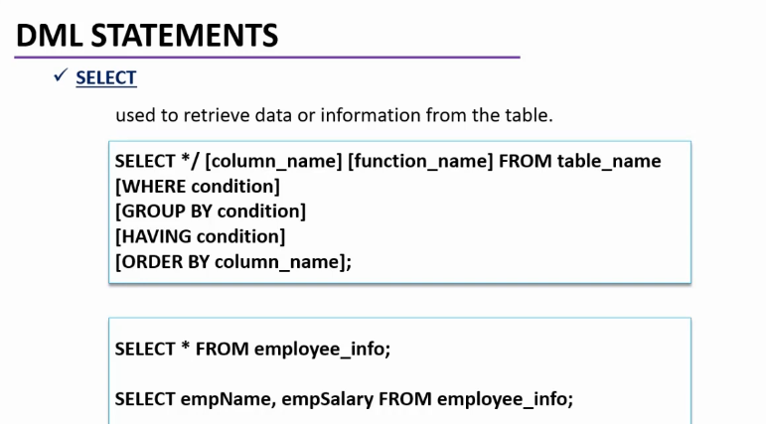

**UPDATE STATEMENT**

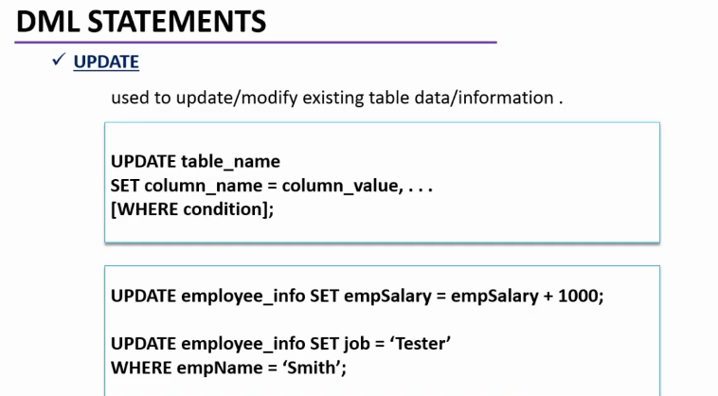

**DELETE STATEMENT**

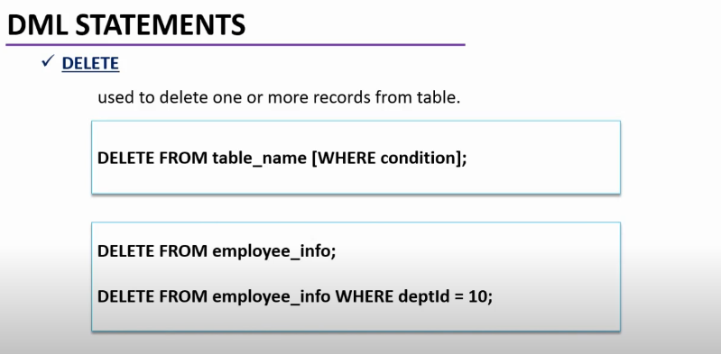

**Rename table and Column:**

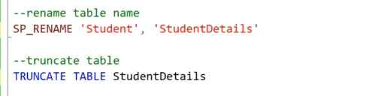

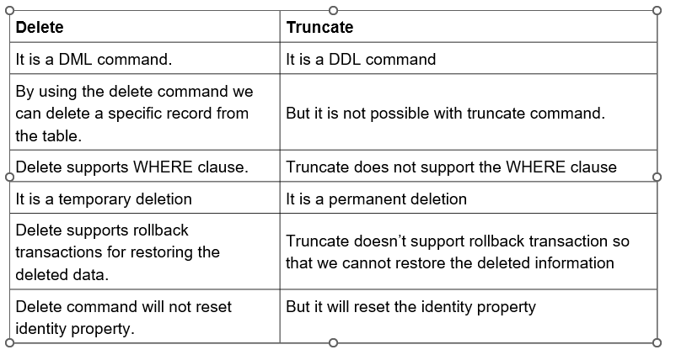

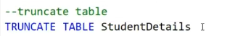

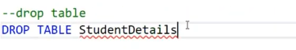

**Identity Column in SQL Server**

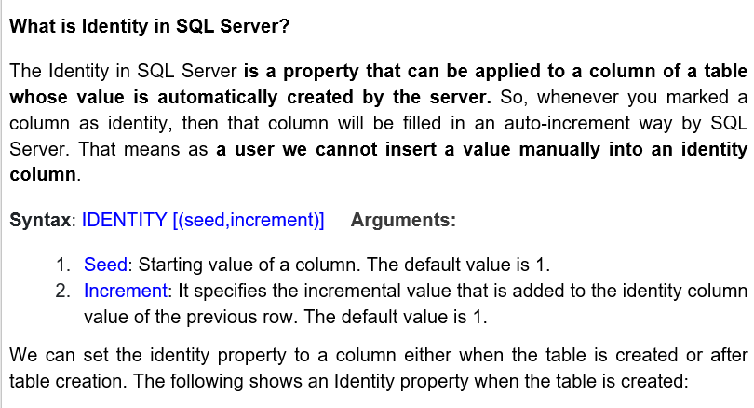

**Example:**

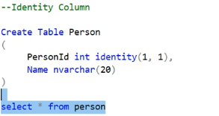

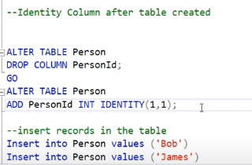

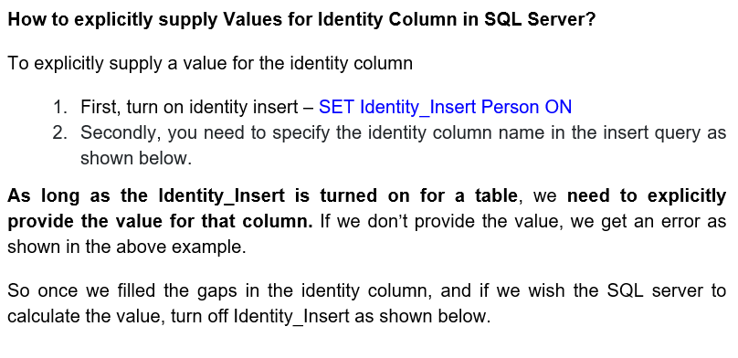

**Example:**

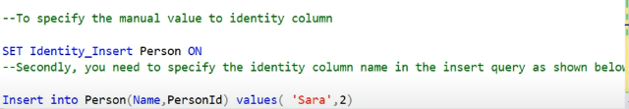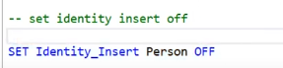

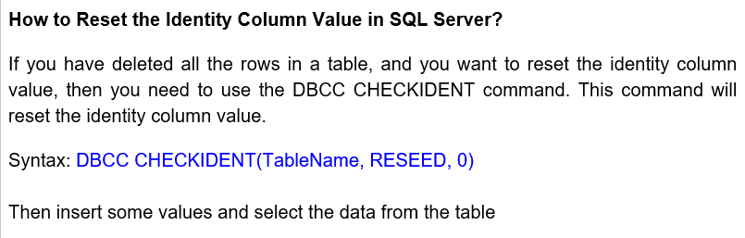

**Example:**

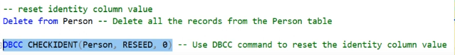

**Sequence Object in SQL Server**

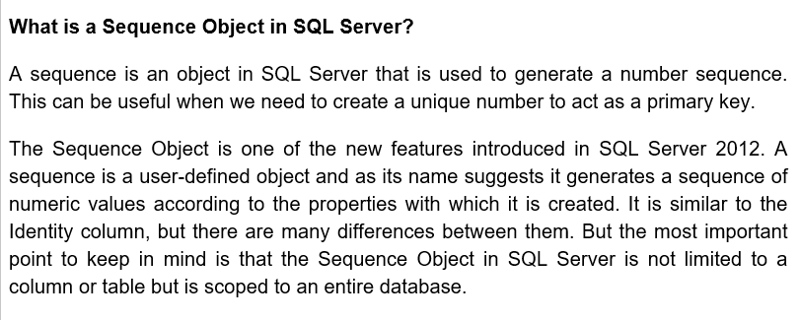

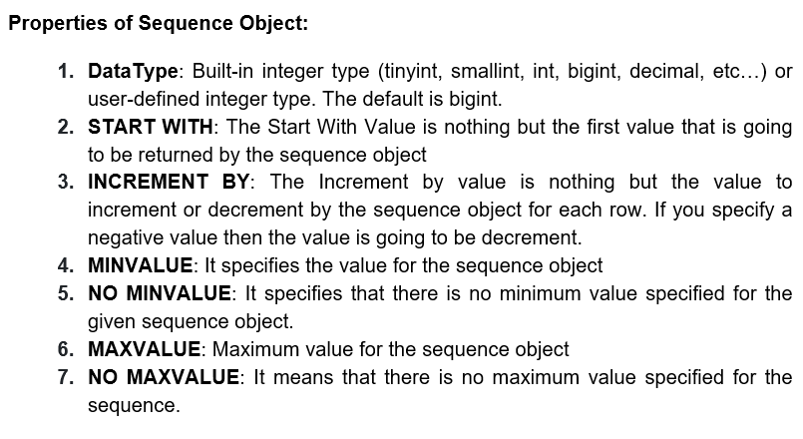

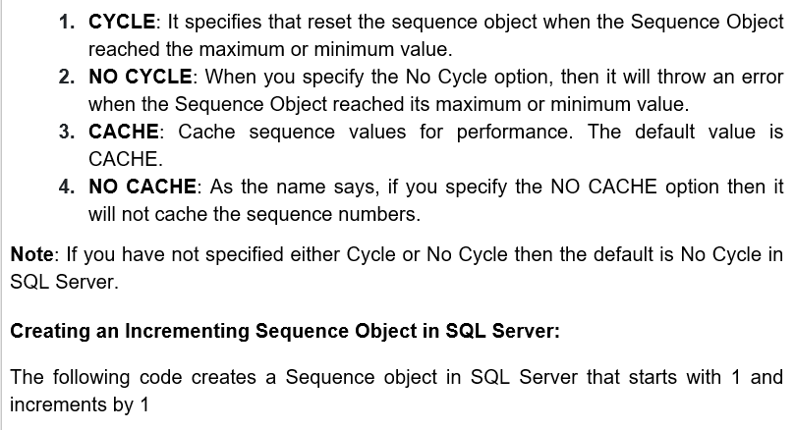

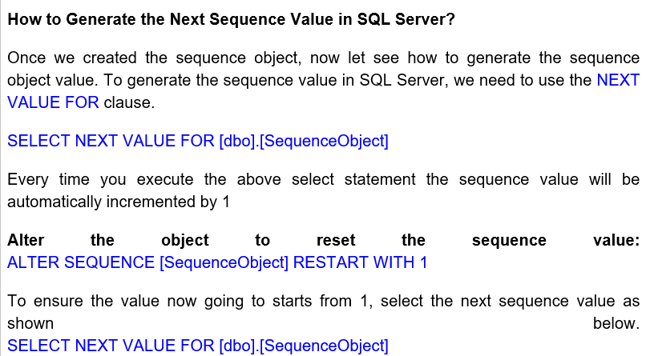

Example

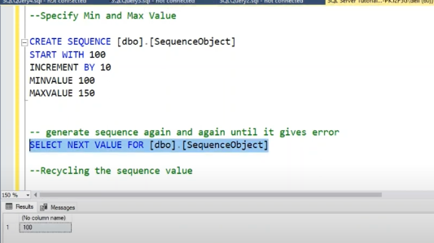

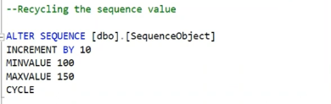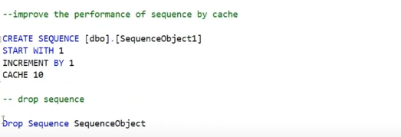

**ORDER BY**

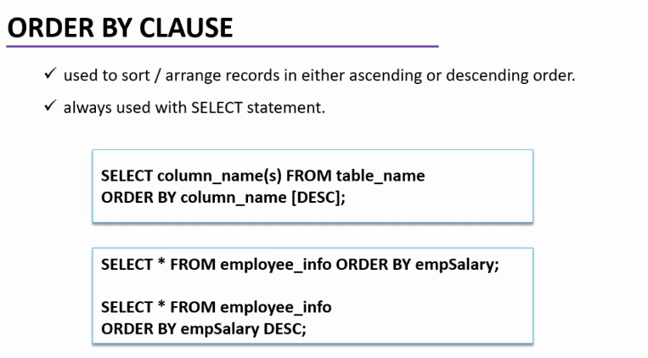

**WHERE clause**

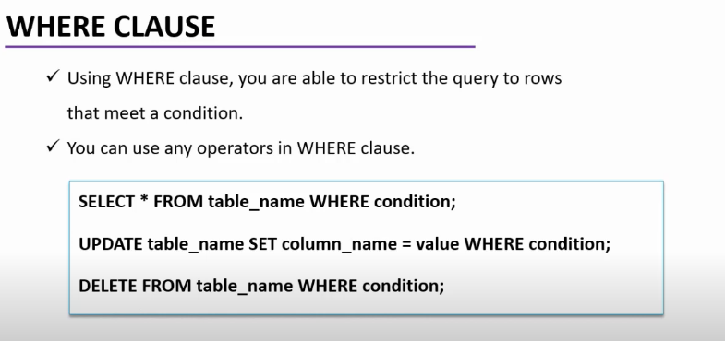

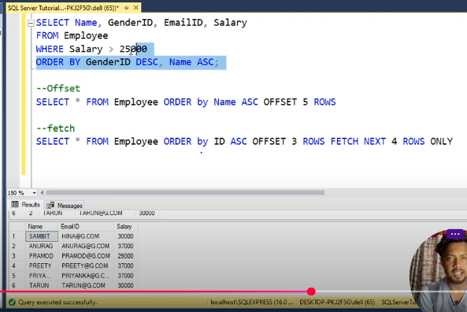

**AGGREGATE FUNCTION**

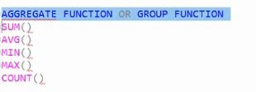

**NUMERIC FUNCTION**

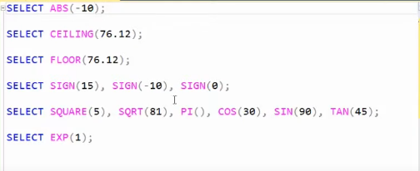

**STRING FUNCTION**

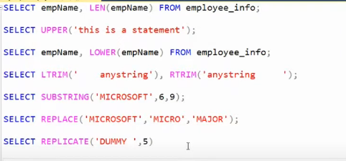

**Boolean Operators**

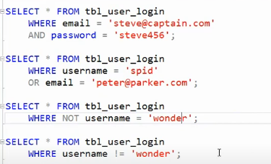

**DATE & TIME FUNCTION:**

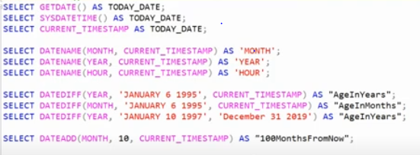

**GROUP BY Clause**

* defines one or more columns as a group such that all rows within any group have the same values for those columns.
* always used with SELECT statement.

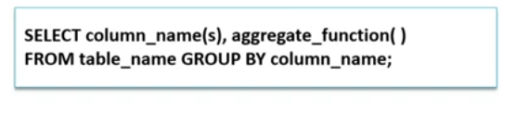

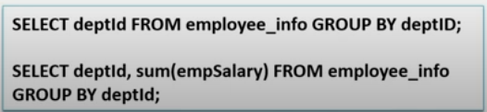

**HAVING Clause**

* The HAVING clause defines the condition that is then applied to groups of rows.
* always used with SELECT statement inside GROUP BY clause.

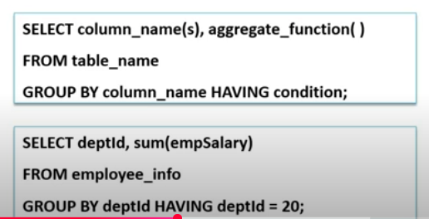

**TOP Clause**

* The TOP clause specifies the first n rows of the query result that are to be retrieved.
* This clause should always be used with the ORDER BY clause

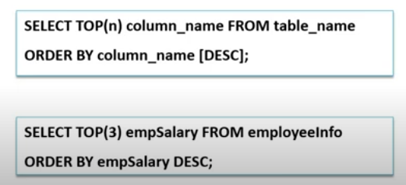

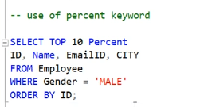

**Over and Partition By Clause**

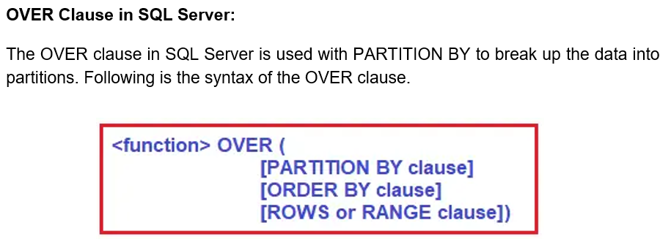

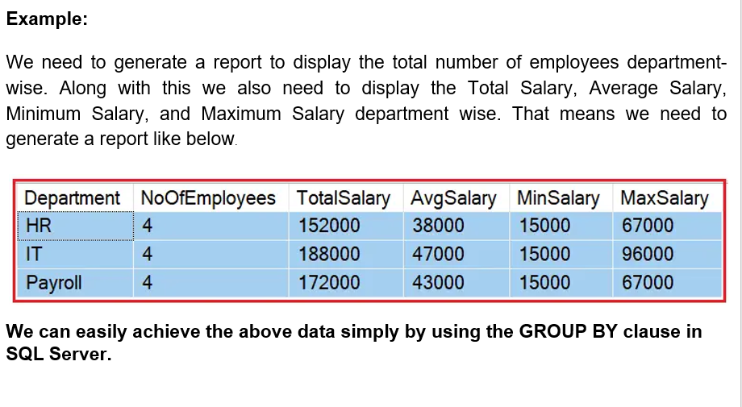

**Example**

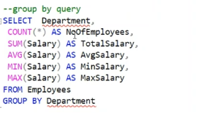

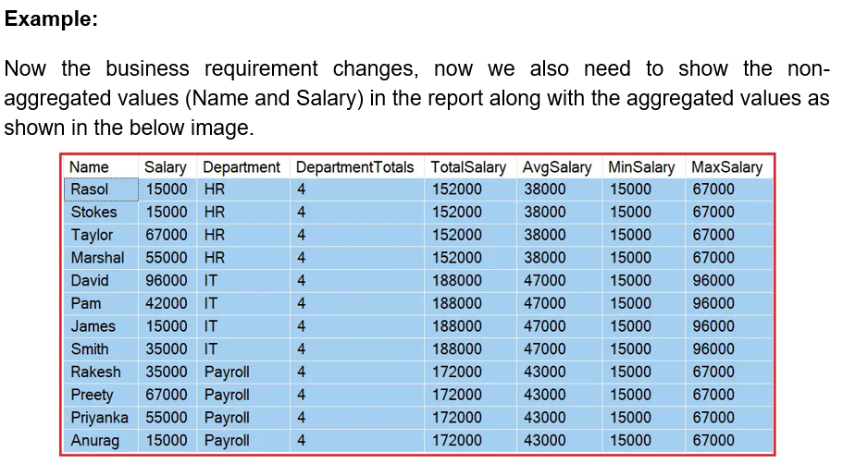

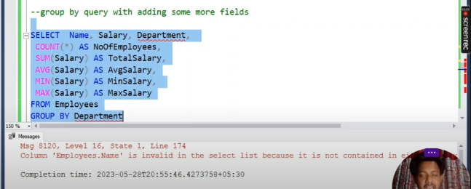

**How can we achieve the desired output?**

**We can get the desired output in two ways.**

**Solution1:**

**One of the ways to get the desired output is by including all the aggregations in a subquery and then JOINING that subquery with the main query.**

**Once you execute the above query then you will get the desired output. But look at the number of T-SQL statements that we wrote.**

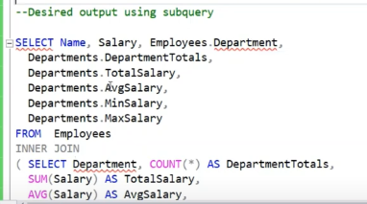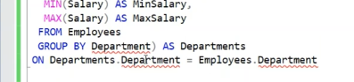

**Solution2:**

**The second way that is the most preferable way to get the desired output is by using the OVER clause combined with the PARTITION BY clause**

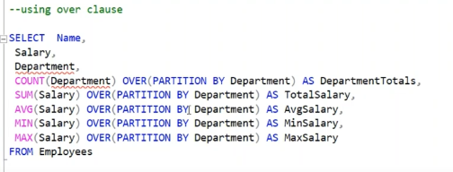

**Row Number Function**

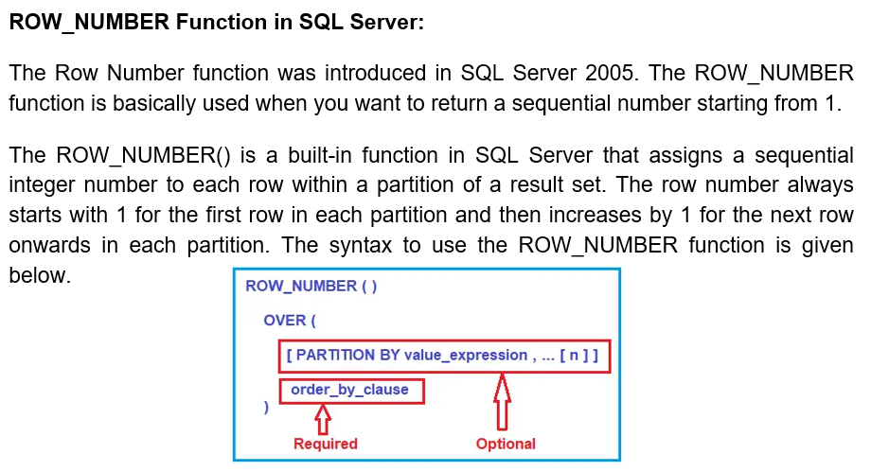

**ROW_NUMBER Function without PARTITION BY:**

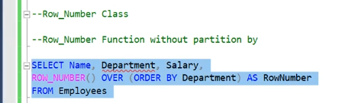

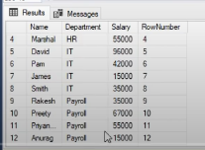

**Row_Number Function with PARTITION BY Clause:**

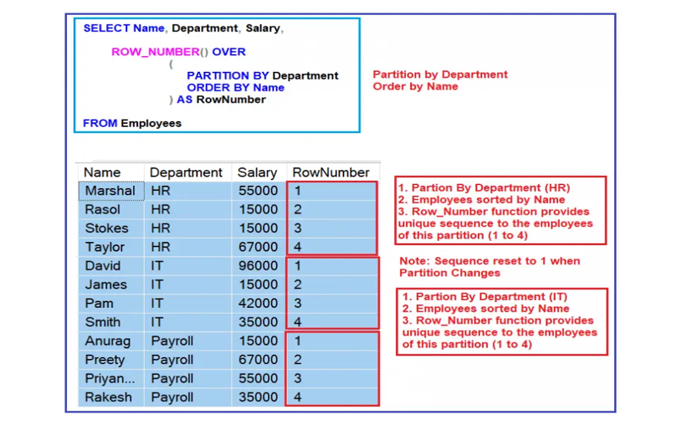

**Example:**

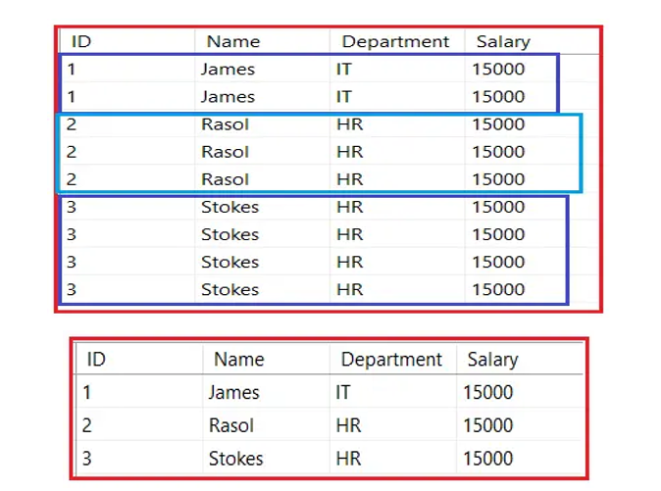

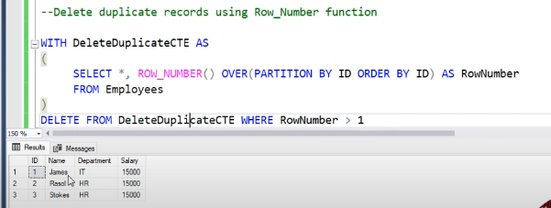

**RANK and DENSE_RANK Function in SQL Server**

**RANK:**

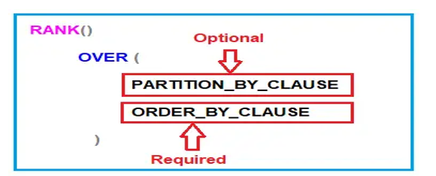

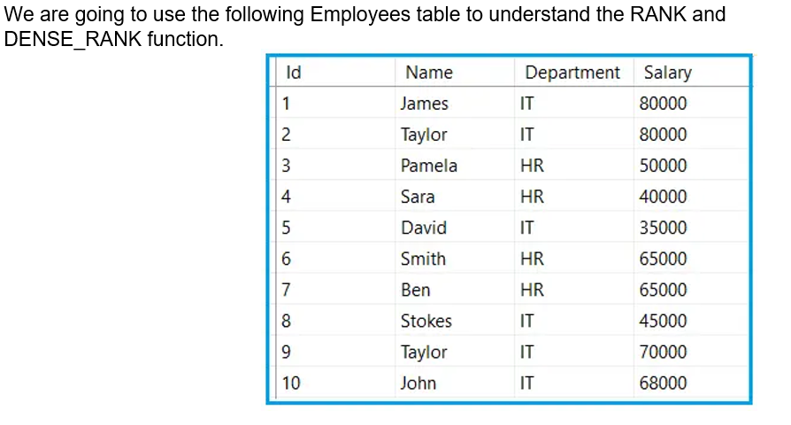

**RANK Function without PARTITION**

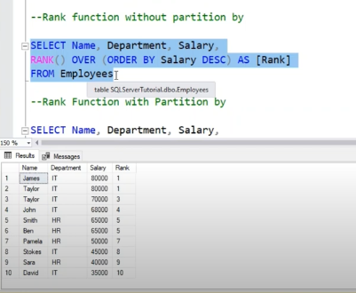

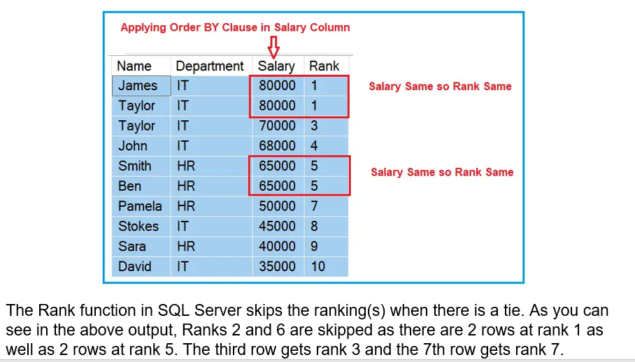

**RANK Function with PARTITION BY clause in SQL Server:**

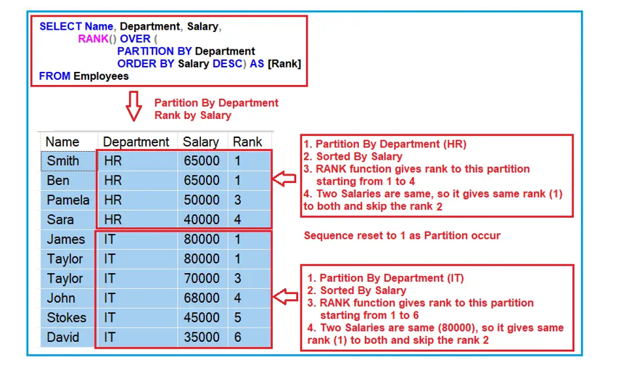

So, in short, The RANK function Returns an increasing unique number for each row starting from 1 and for each partition. When there are duplicates, the same rank is assigned to all the duplicate rows, but the next row after the duplicate rows will have the rank it would have been assigned if there had been no duplicates. So the RANK function skips rankings if there are duplicates.

**DENSE_RANK Function in SQL Server:**

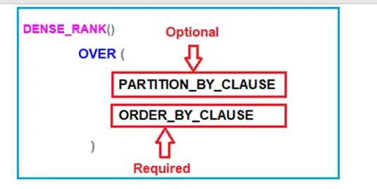

**DENSE_RANK Function without PARTITION BY clause in SQL Server:**

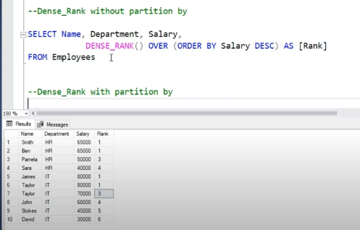

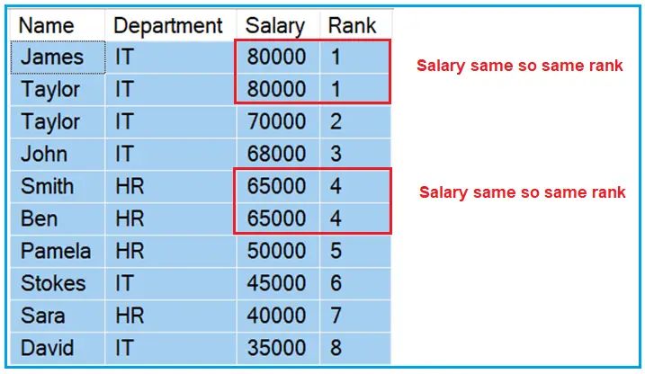

**DENSE_RANK Function with PARTITION BY clause in SQL Server:**

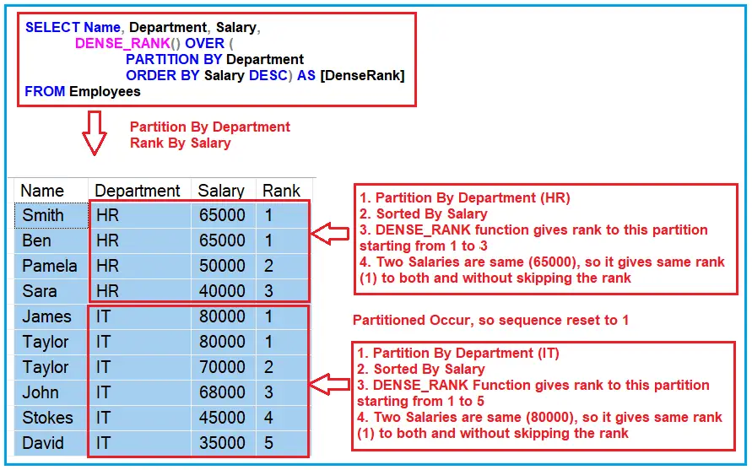

**The Real-time examples of RANK and DENSE_RANK Functions in SQL Server:**

**Find the nth highest salary. Both the RANK and DENSE_RANK functions can be used to find nth highest salary.**

**Fetch the 2nd Highest Salary using the RANK function:**

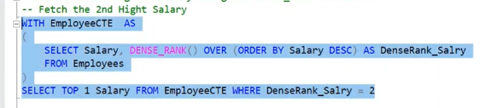

**Since, in our Employees table, we have 2 employees with the FIRST highest salary (80000), the Rank() function will not return any data for the SECOND highest Salary. Please execute the below SQL Script and see the output.**

**Between and Like Operators**

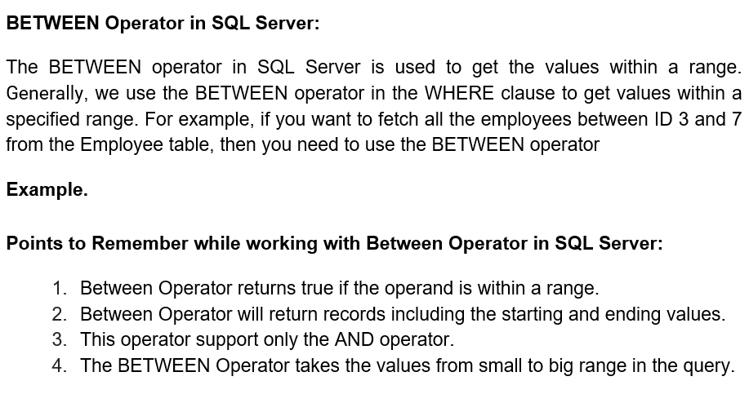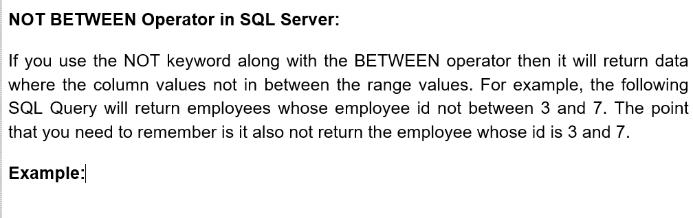

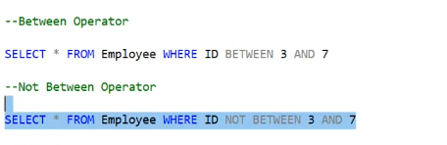

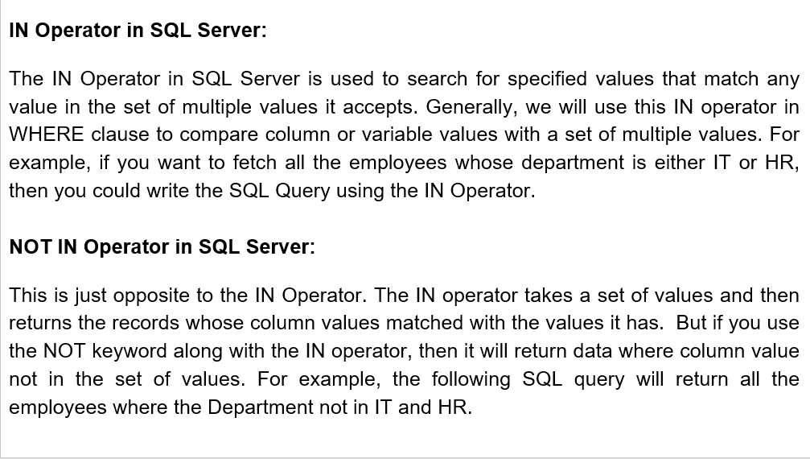

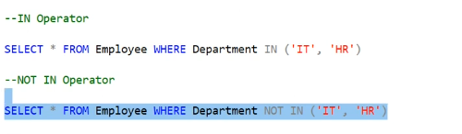

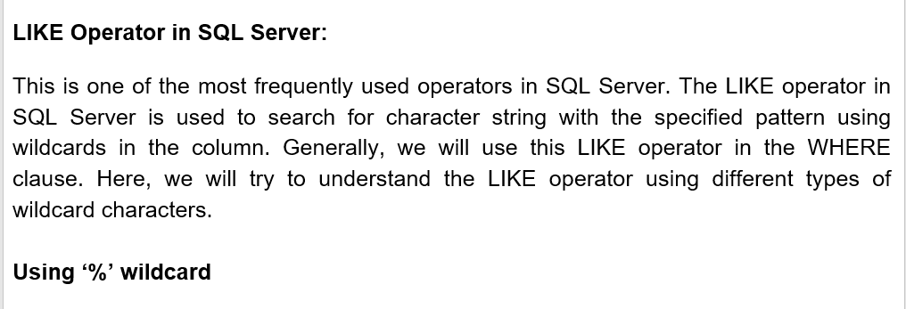

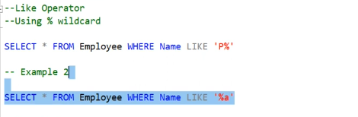

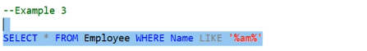

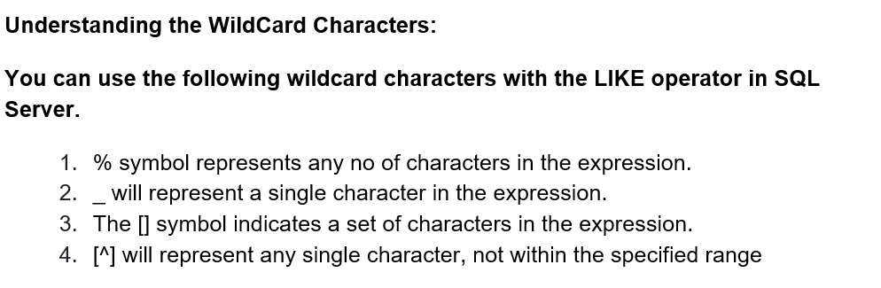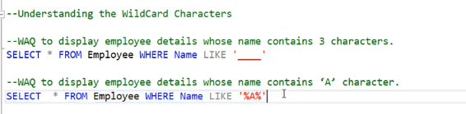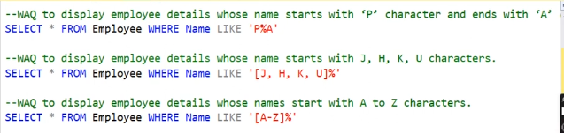

**All and Any Operator in SQL Server**

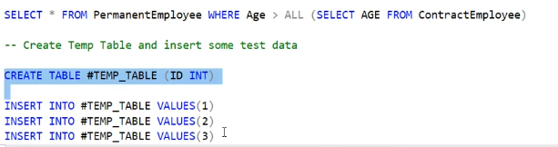

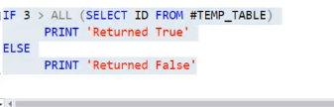 **O/P: Returned True**

**Exists Operator**

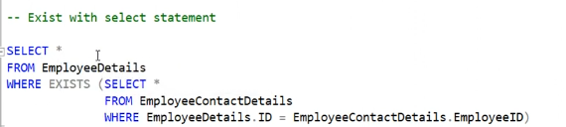

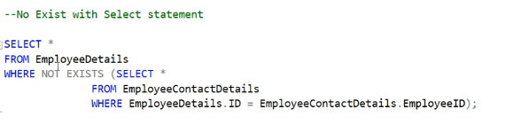

**Intersect Operator in SQL Server**

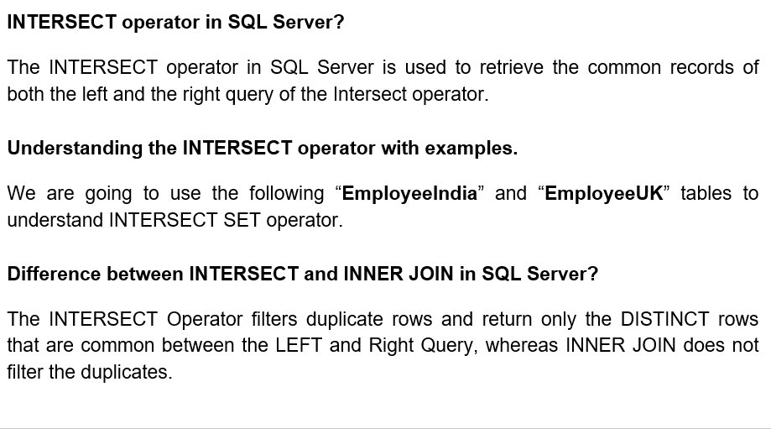

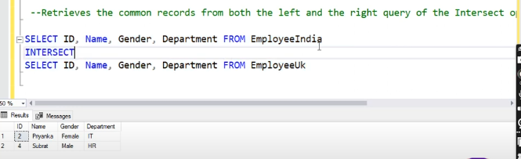

**Except Operator in SQL Server: Return data employeeiIndia data which are not present in employeeUK**

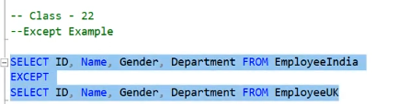

**Union and Union All Operator**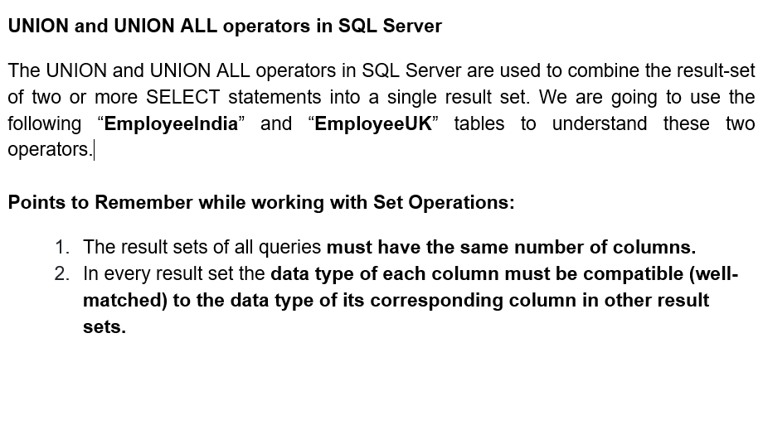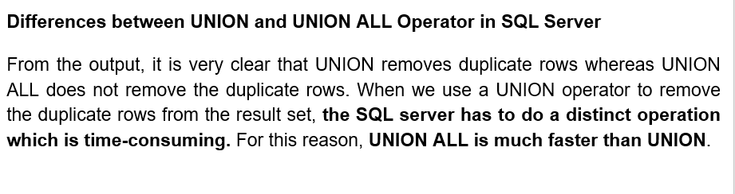

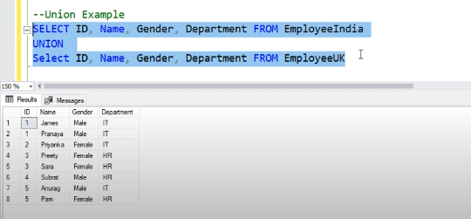

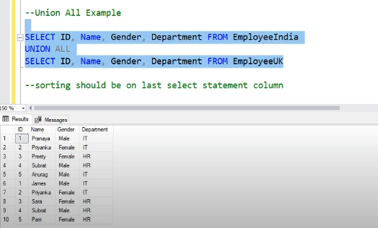

**Coping data from one database to another in SQL Server**

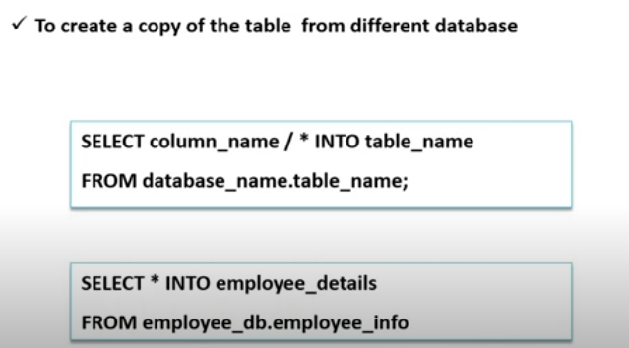

**ALTER STATEMENT (Part I - Add new columns in an existing table)**

* Modifies a table definition by adding, altering, or dropping columns and constraints.
* It also reassigns and rebuilds partitions, or disables and enables constraints and triggers.

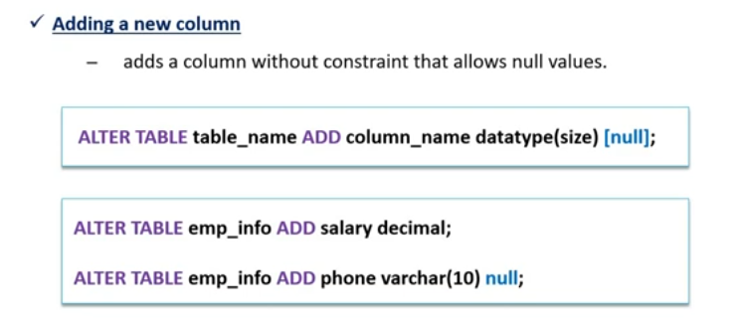

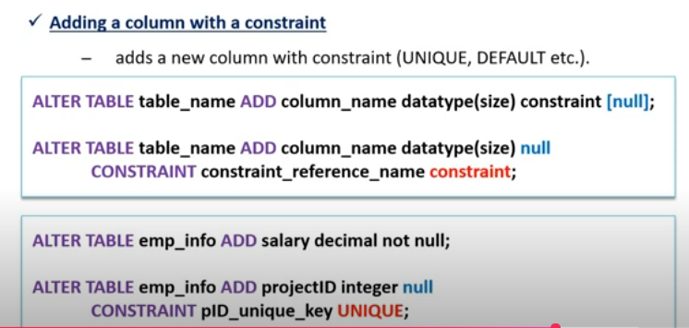

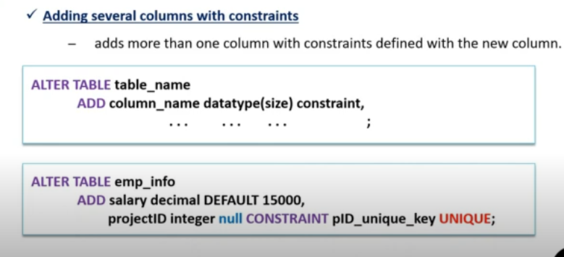

**ALTER STATEMENT (Part II - Drop column and constraint from table)**

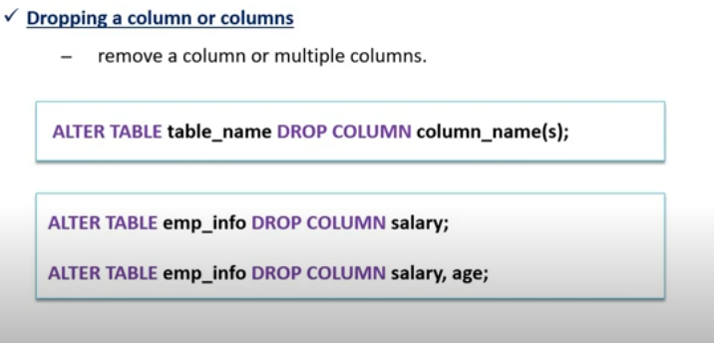

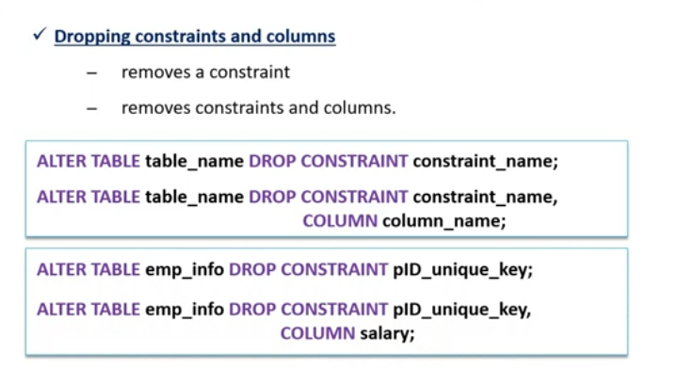

**ALTER STATEMENT (Part III - Altering an existing table)**

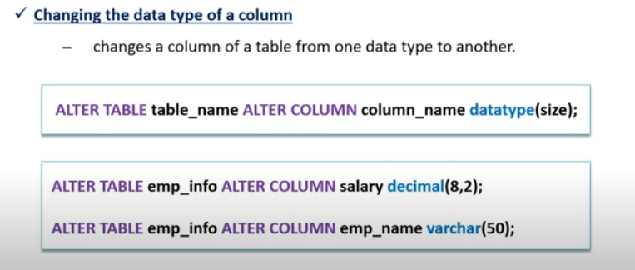

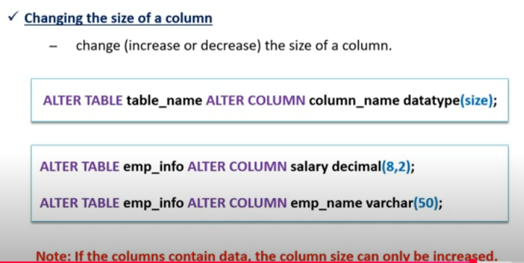

**Aliases in SQL Server**

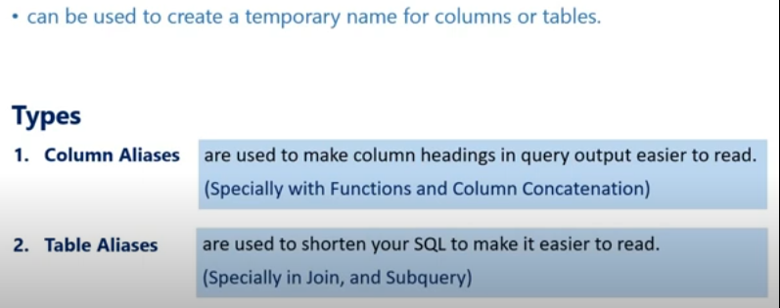

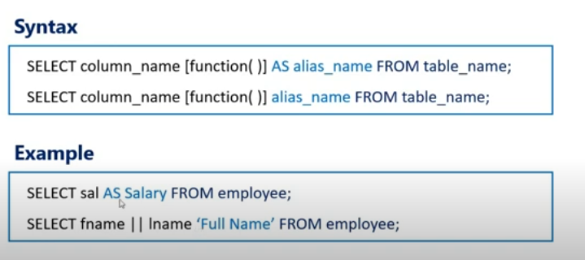

**Joins in SQL Server**

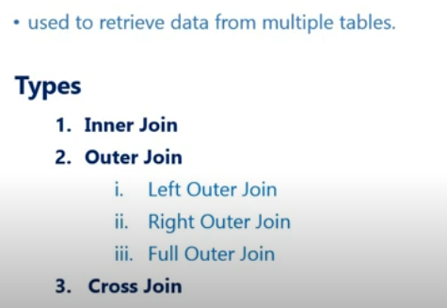

**Inner Join**

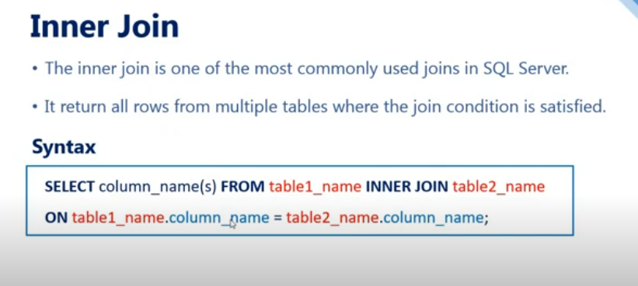

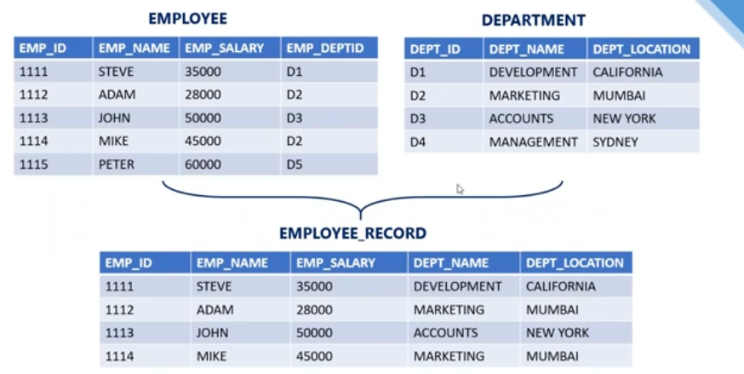

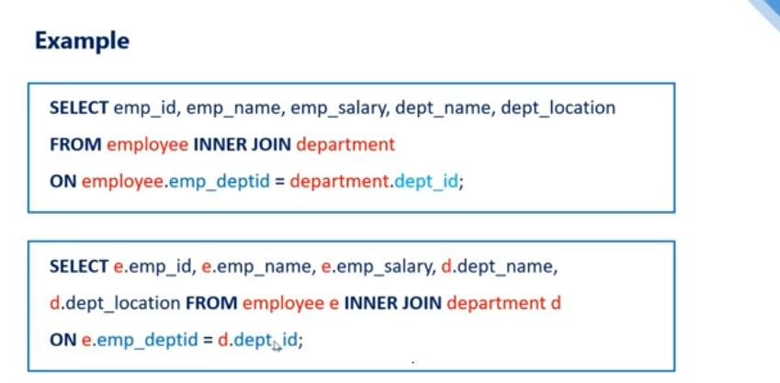

**Left Outer Join**

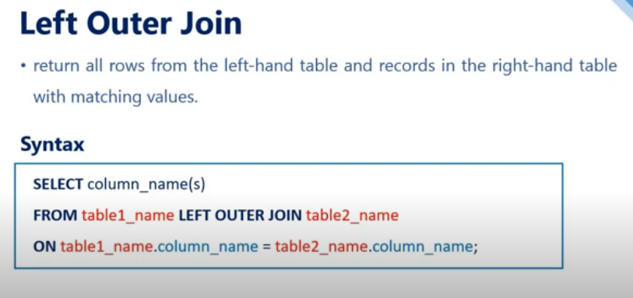

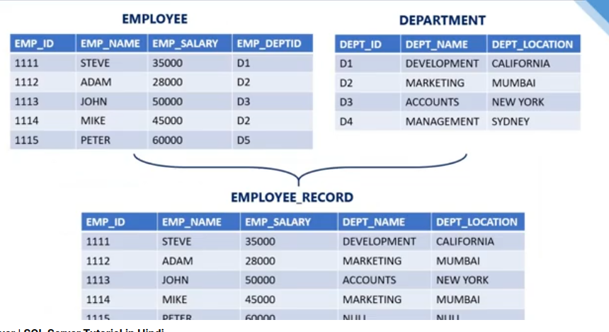

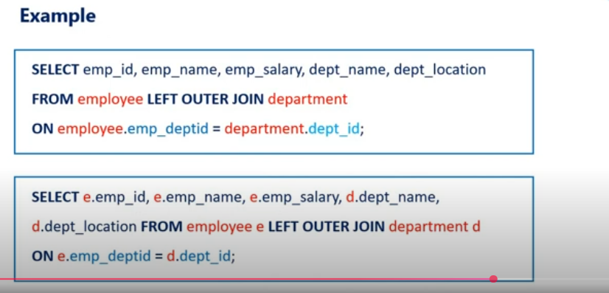

**Right Outer Join**

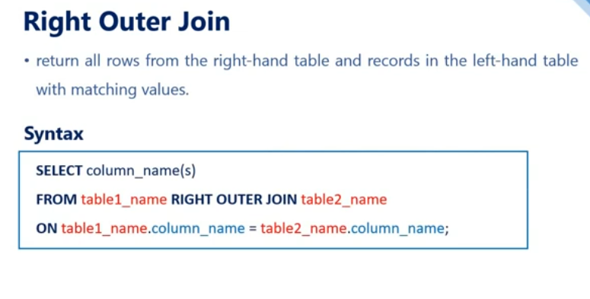

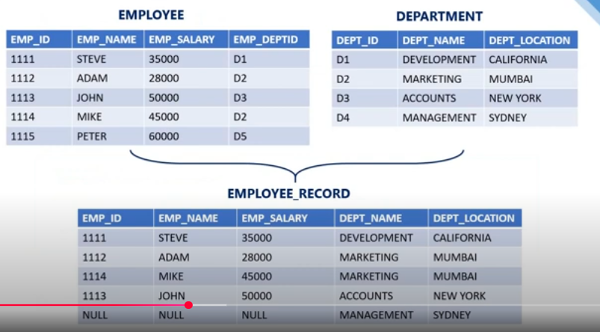

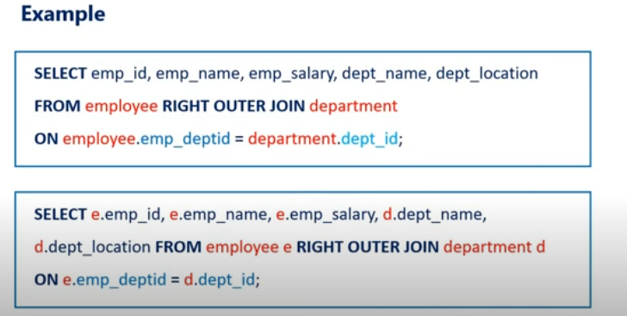

**Full Outer Join**

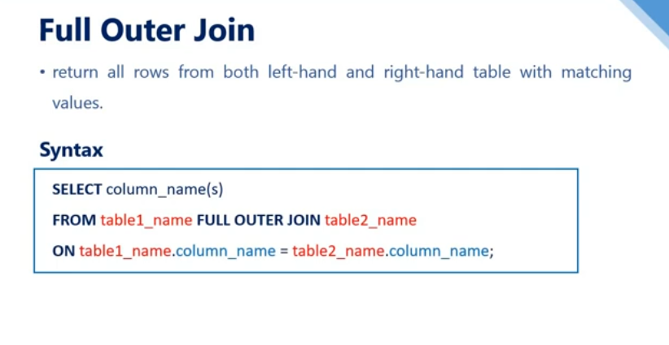

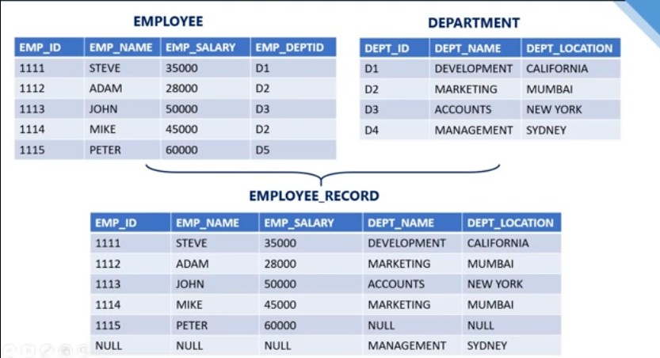

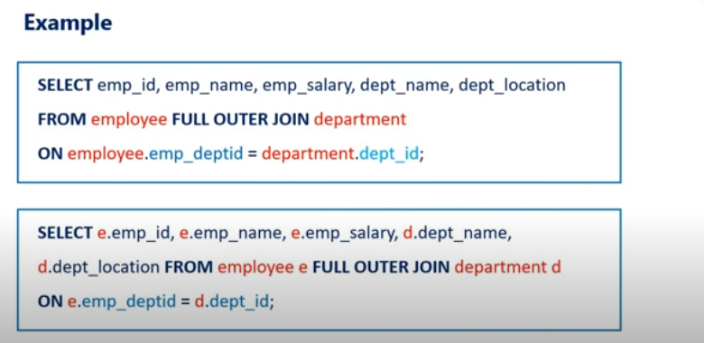

**Self Join in SQL Server**

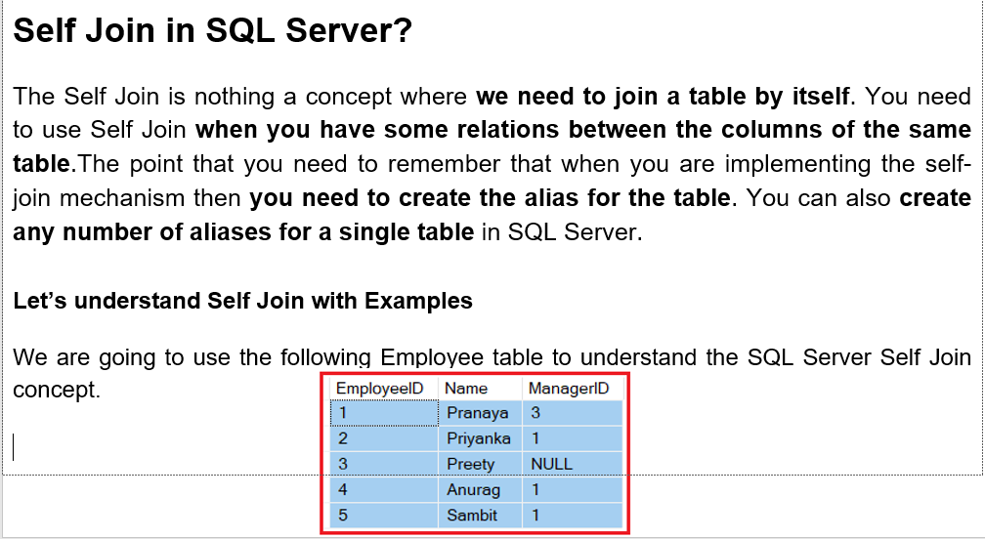

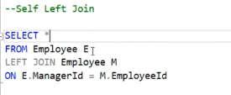

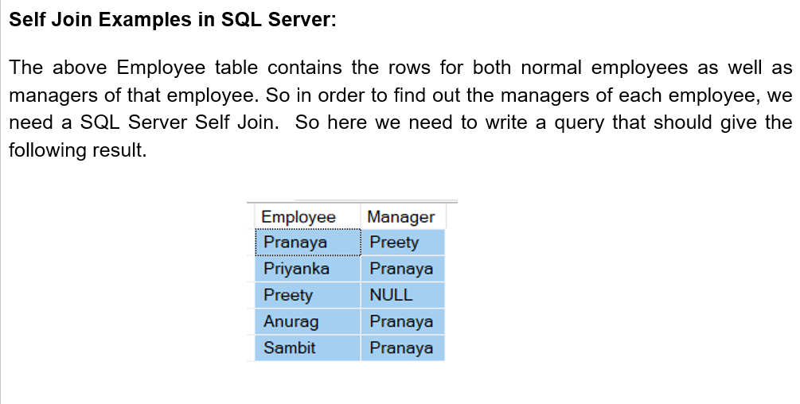

**Cross Join**

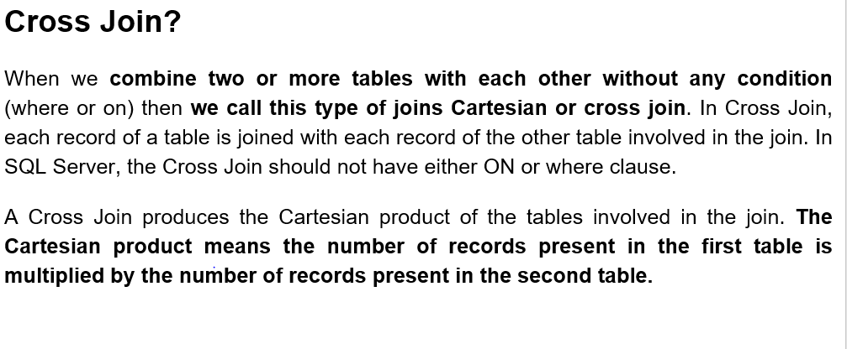

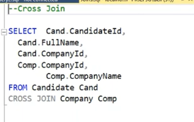

**Subquery**

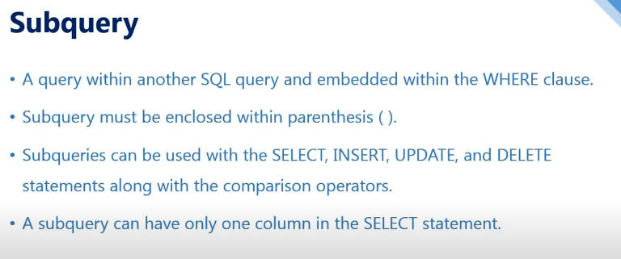

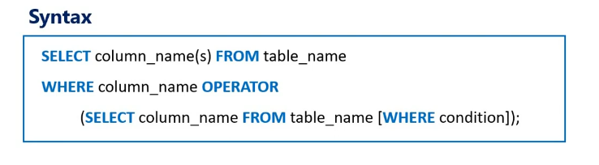

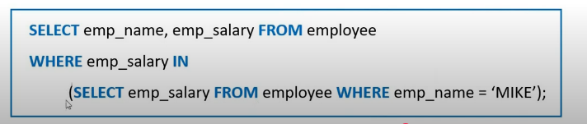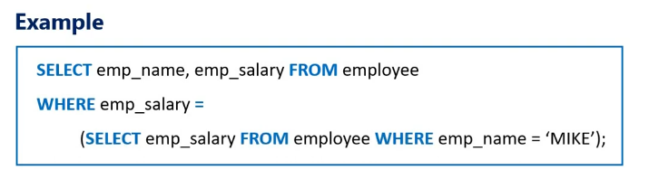

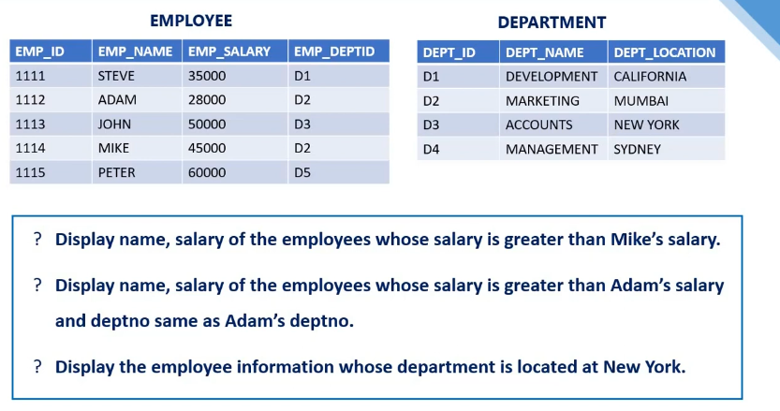

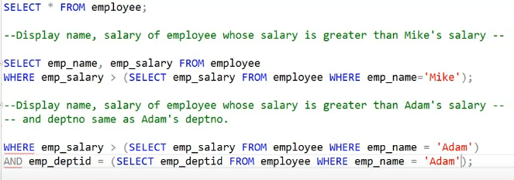

**Introduction to T-SQL**

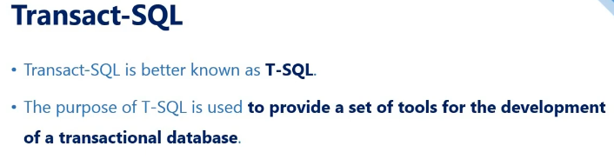

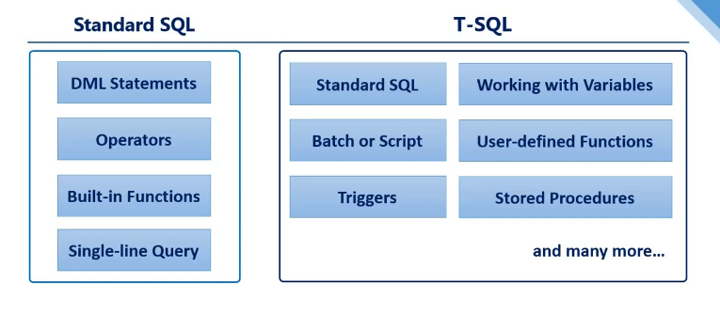

**Working with Variables**

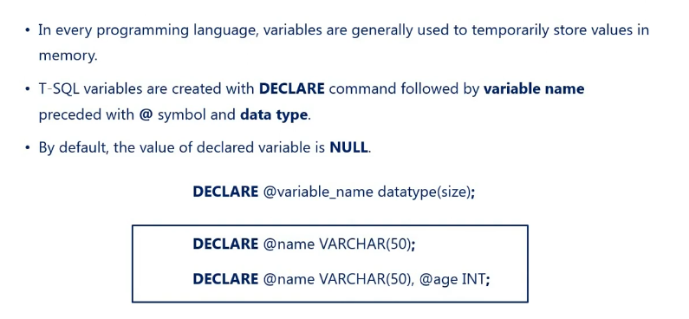

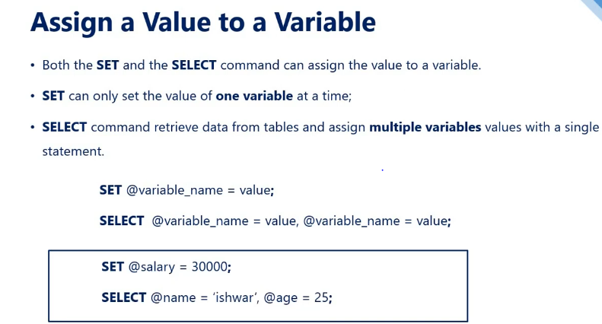

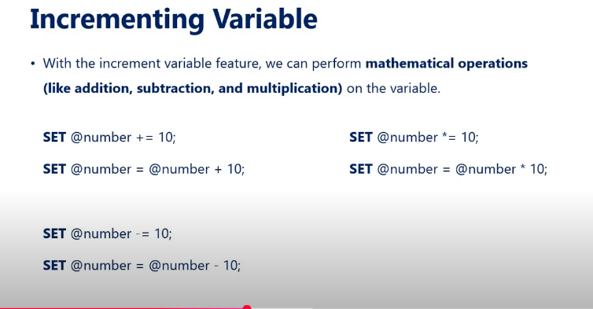

**Script**

Learned how to generate Scripts from database

**Batch in T-SQL**

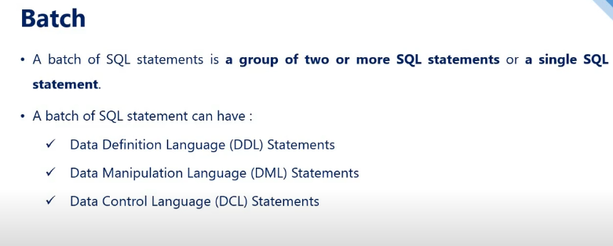

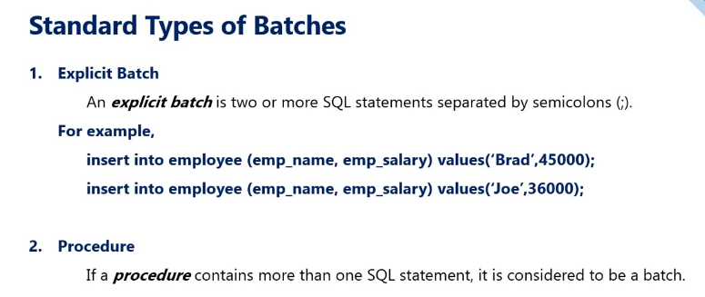

**Go Command**

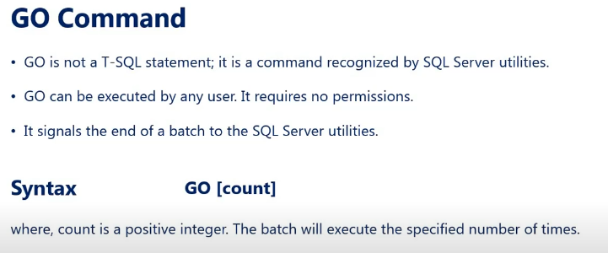

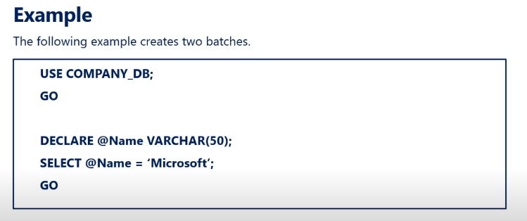

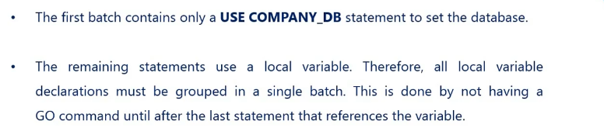

**Control Flow Keywords**

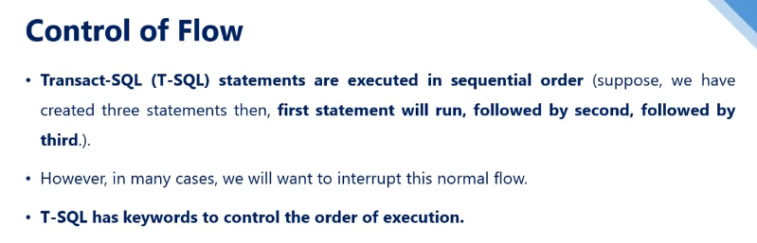

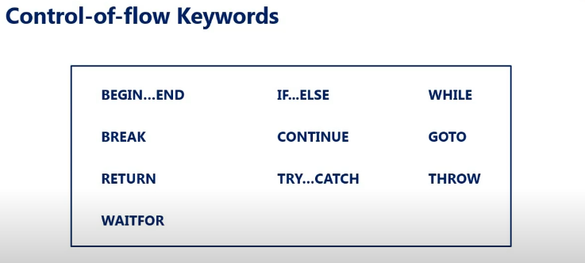

**BEGIN...END**

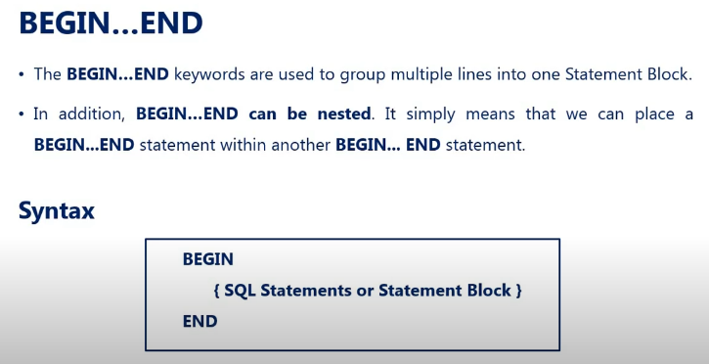

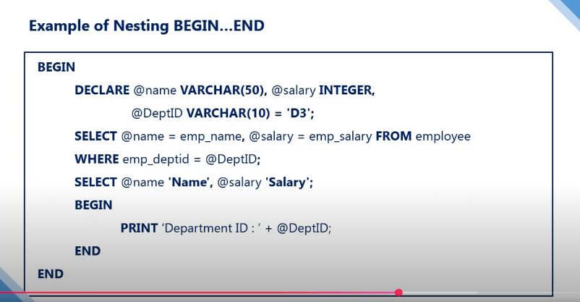

**IF...ELSE**

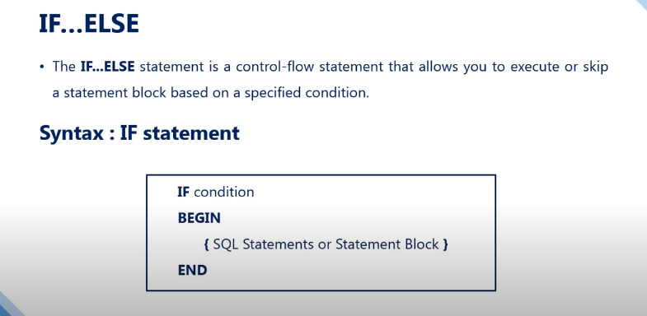

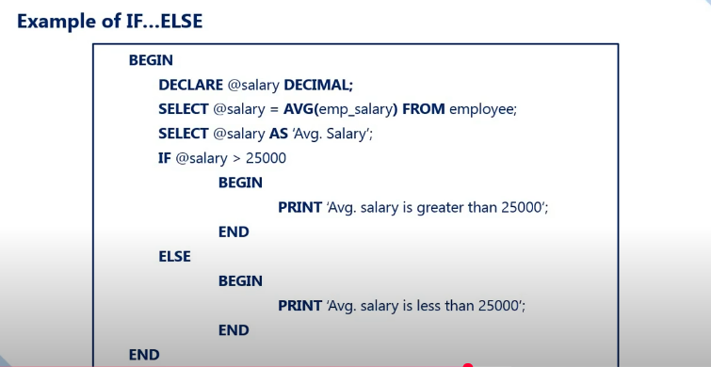

**WHILE Loop**

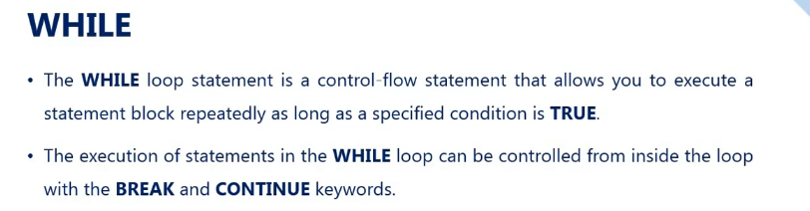

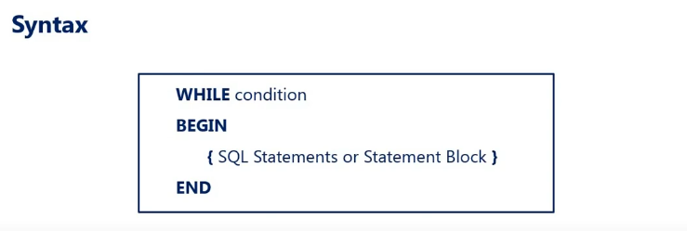

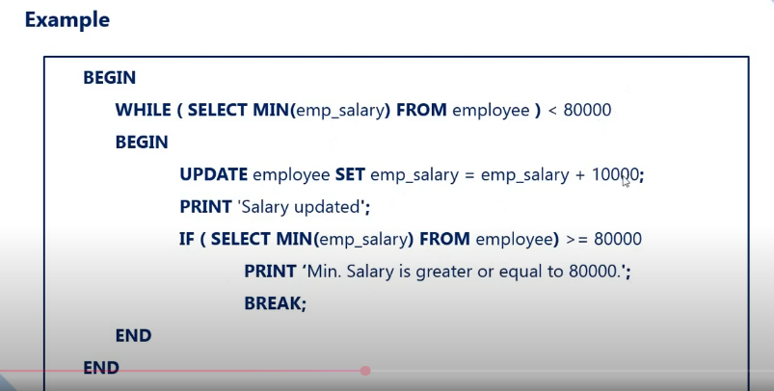

**TRY...CATCH**

**With the introduction of Try/Catch blocks in SQL Server 2005, the error handling in the SQL server is now very much similar to programming languages like C#, and Java. But, before understanding the error handling using the try/catch block, let’s step back and understand how error handling was done in SQL Server prior to 2005, using the system function RAISERROR and @@Error.**

**Exception Handling Using RAISERROR System Function in SQL Server:**

**The system-defined Raiserror() function returns an error message back to the calling application. The RaiseError System defined Function in SQL Server takes 3 parameters as shown below.**

**RAISERROR(‘Error Message’, ErrorSeverity, ErrorState)**

**@@Error System Function in SQL Server:**

**In SQL Server 2000, in order to detect errors, we use the @@Error system function. The @@Error system function returns a NON-ZERO value if there is an error, otherwise, ZERO indicates that the previous SQL statement was executed without any error. Let’s modify the stored procedure to make use of the @@ERROR system function**

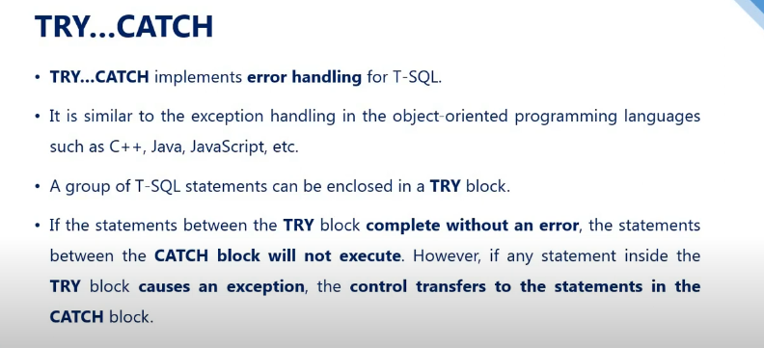

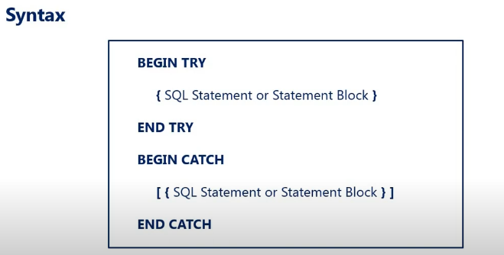

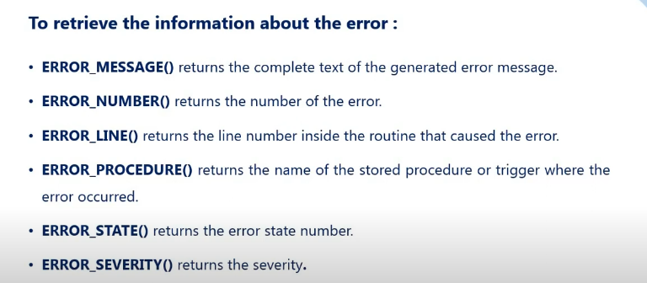

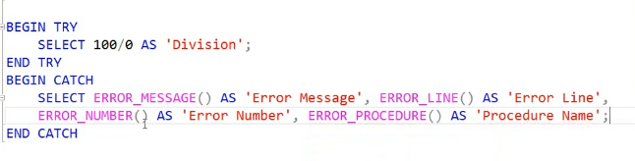

**WAITFOR**

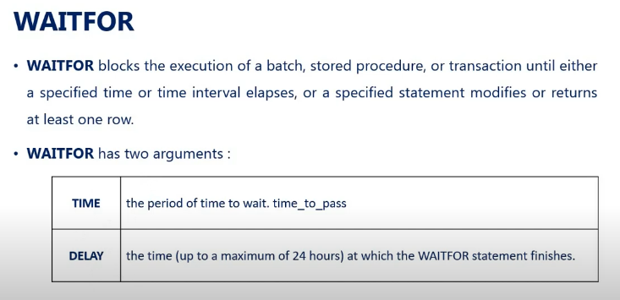

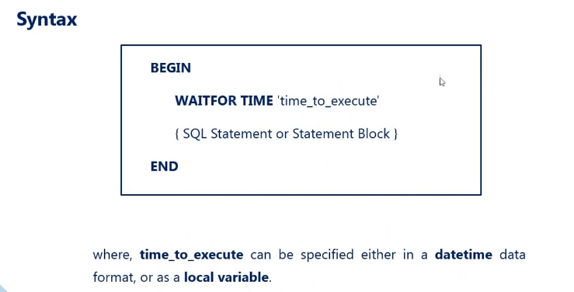

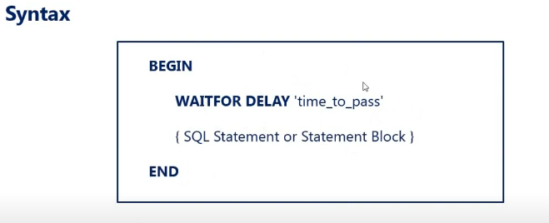

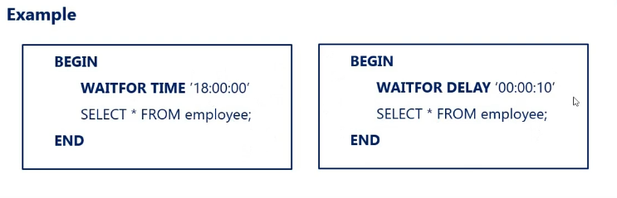

**Stored procedure in T-SQL**

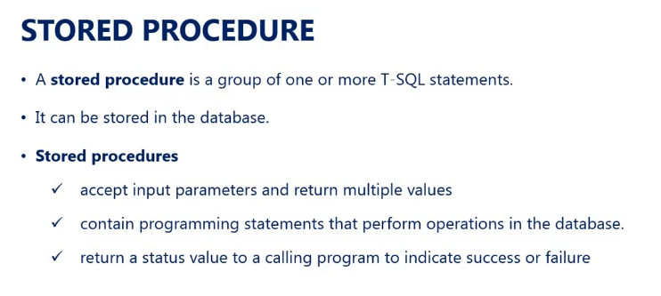

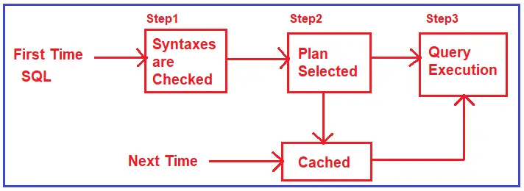

**What is a Stored Procedure in SQL Server?**

A SQL Server Stored Procedure is a database object which contains pre-compiled queries (a group of T-SQL Statements). In other words, we can say that the Stored Procedures are a block of code designed to perform a task whenever we called.

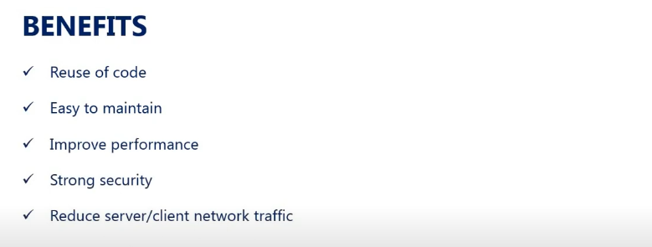

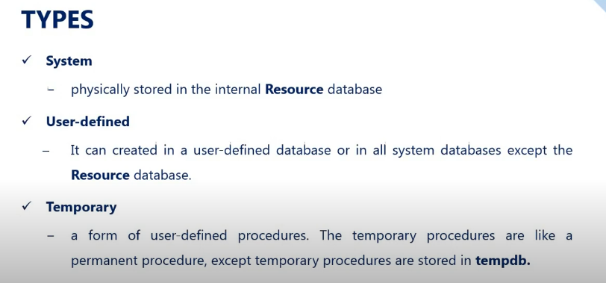

**Create Stored Procedure in T-SQL**

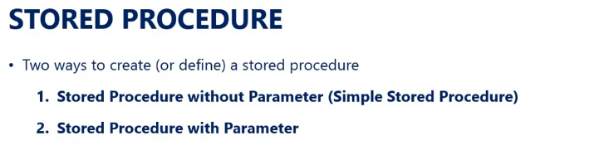

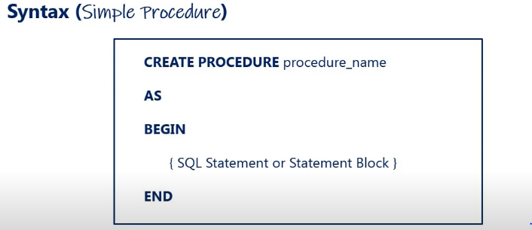

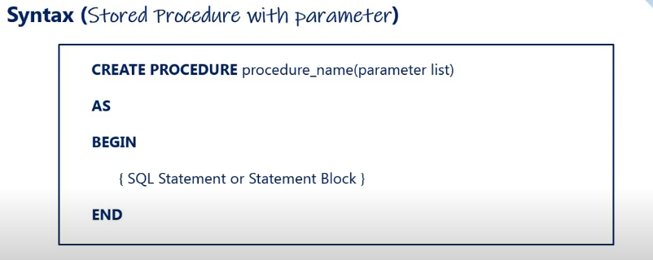

**Different Types of Parameters in SQL Server Stored Procedure.**

1. Input parameters
2. Output parameters

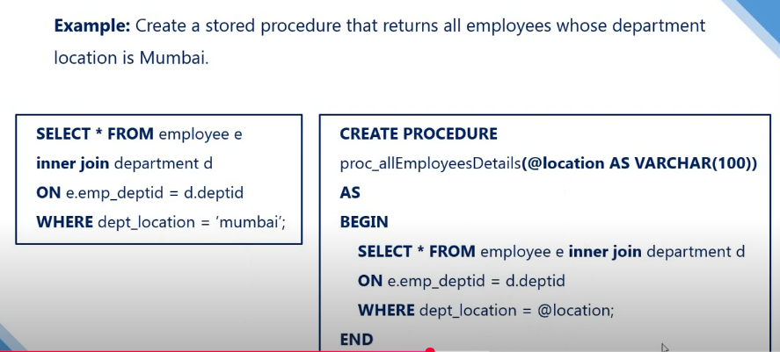

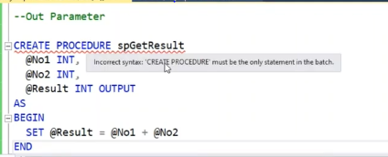

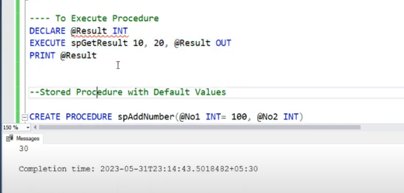

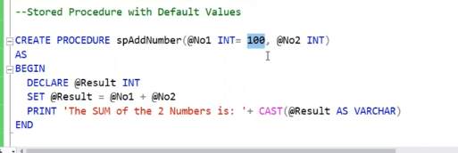

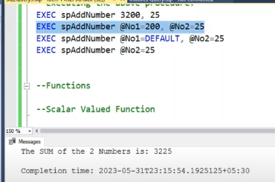

**How to call a Stored Procedure in SQL Server?**

Once we create the stored procedure, then it is physically stored on the server as a “database object” which can be called from anywhere connecting to the server.

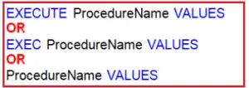

**Alter (Modify) a Stored Procedure**

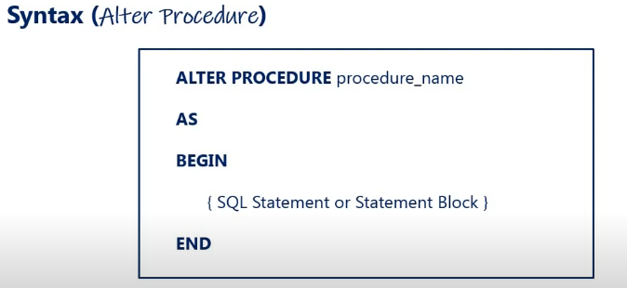

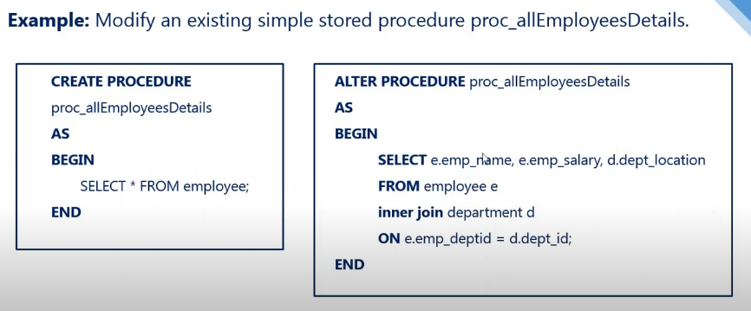

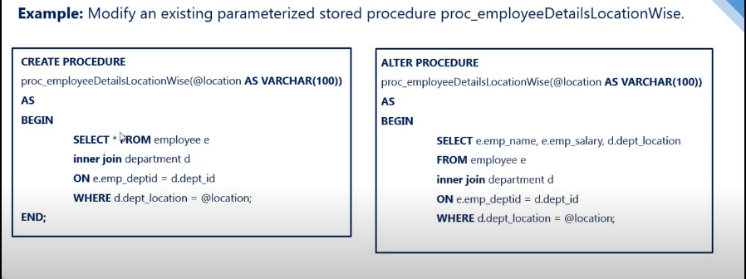

**Rename a Stored Procedure**

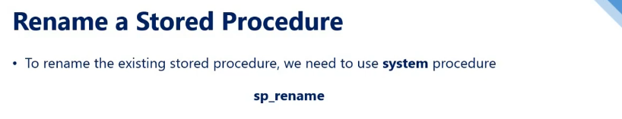

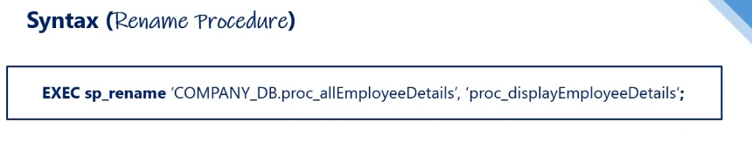

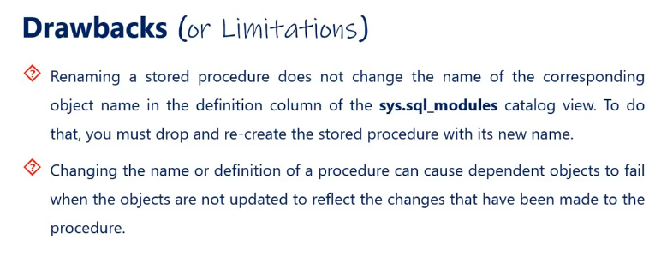

**User-defined Functions in T-SQL**

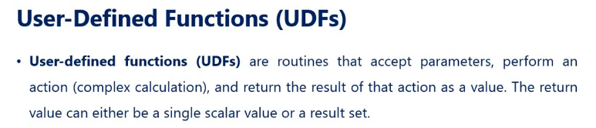

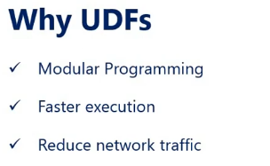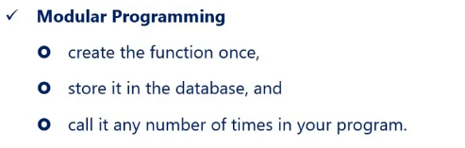

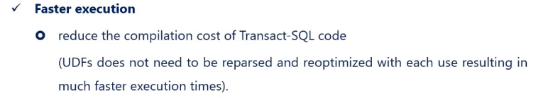

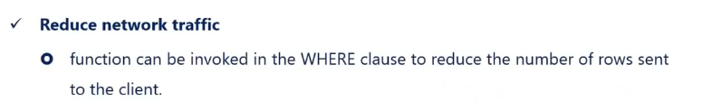

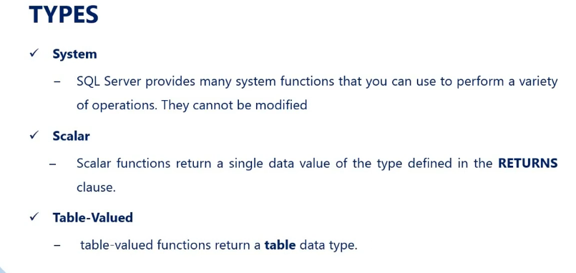

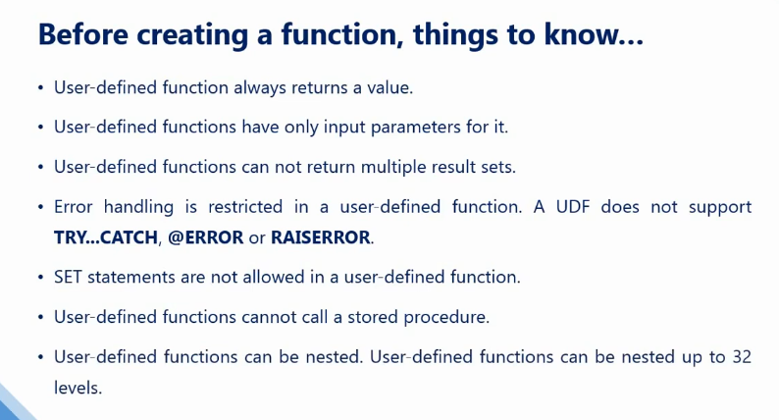

**Scalar-Valued Function (Create)**

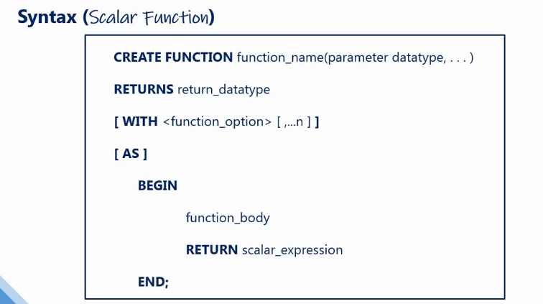

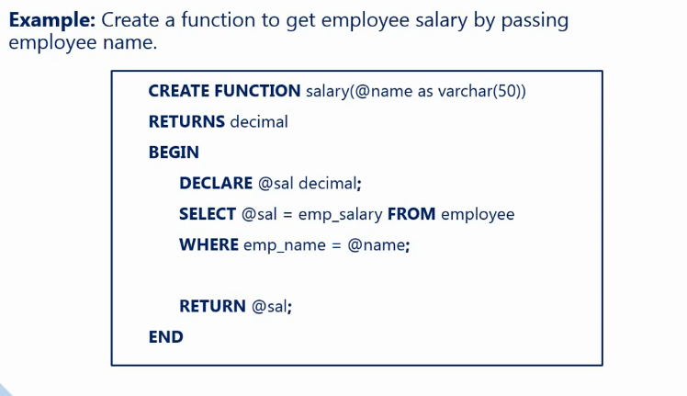

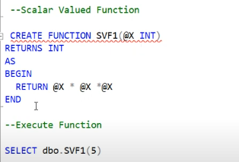

**A stored procedure can also accept the DOB of an employee and return the age but we cannot use a stored procedure in a select clause or where clause. This is one of the differences between a function and a stored procedure.**

**Table-valued Function in T-SQL**

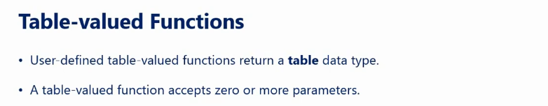

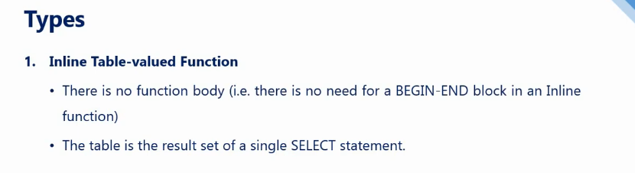

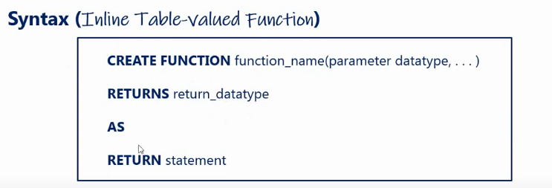

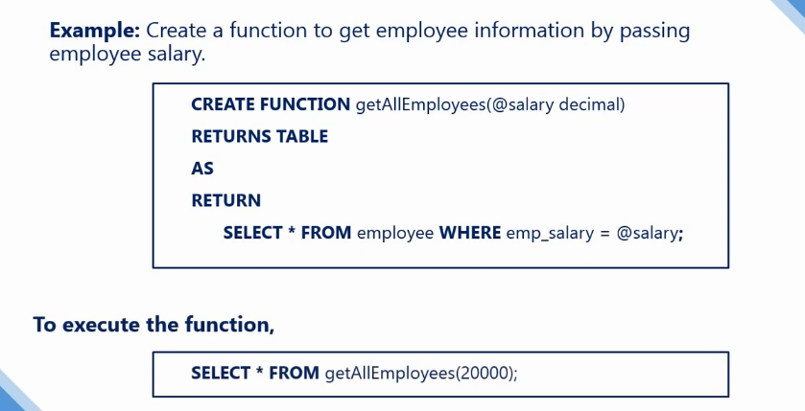

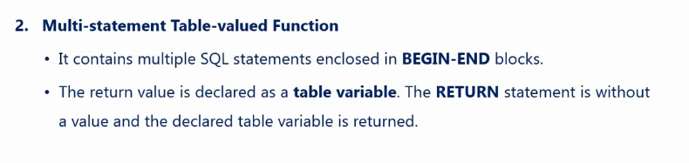

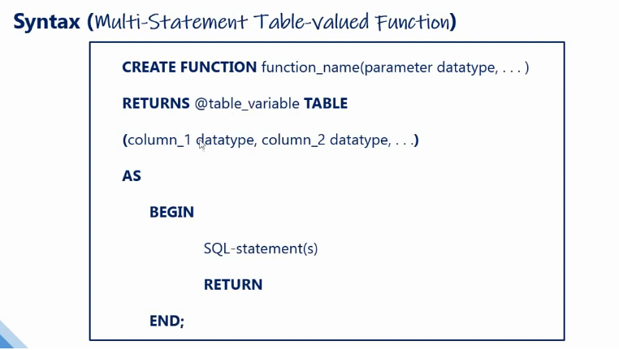

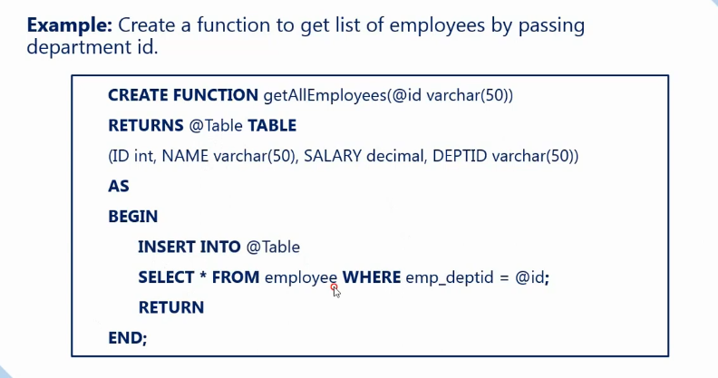

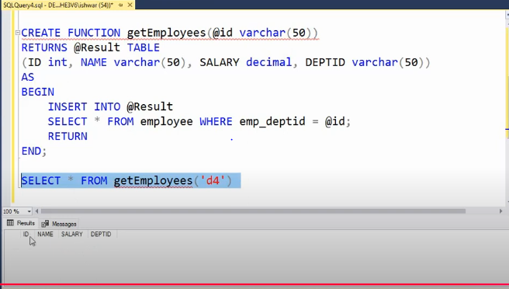

**What is the Difference Between Functions and Procedures in SQL Server?**

1. A function must return a value, it is mandatory whereas a procedure returning a value is optional.
2. The procedure can have parameters of both input and output whereas a function can have only input parameters.
3. In a procedure, we can perform Select. Update, Insert and Delete operations whereas function can only be used to perform select operations. It cannot be used to perform Insert, Update, and Delete operations that can change the state of the database.
4. A procedure provides the options to perform Transaction Management, Error Handling, etc whereas these operations are not possible in a function.
5. We call a procedure using EXECUTE/ EXEC command whereas a function is called by using SELECT command only.
6. From a procedure, we can call another procedure or a function whereas from a function we can call another function but not a procedure.
7. User-Defined Functions can be used in the SQL statements anywhere in the WHERE/HAVING/SELECT section where as Stored procedures cannot be.

**Introduction to Triggers in T-SQL**

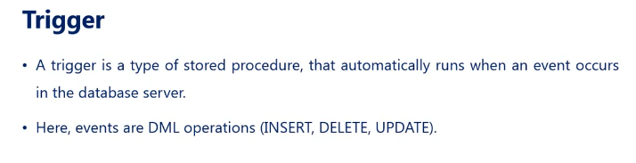

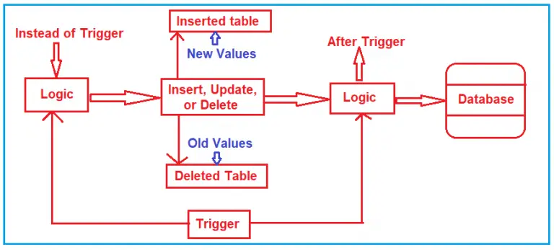

DML Trigger:

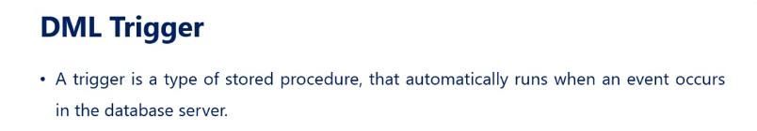

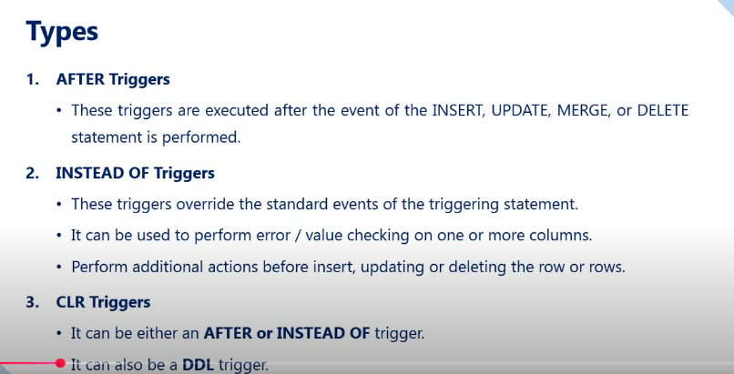

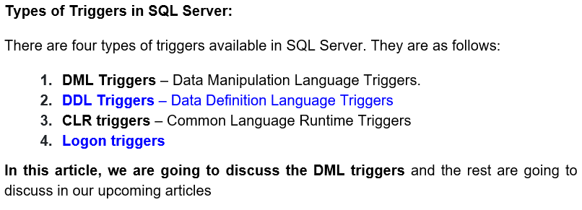

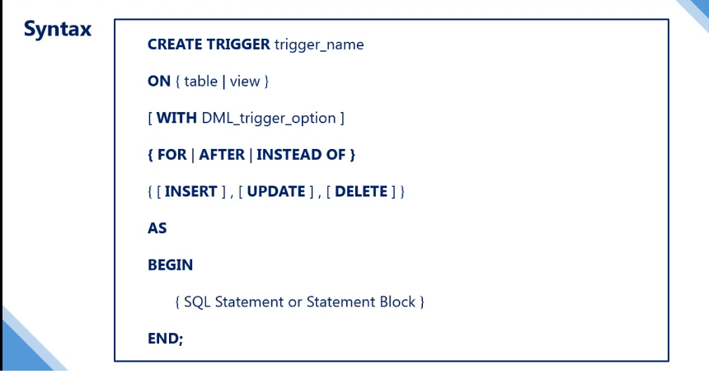

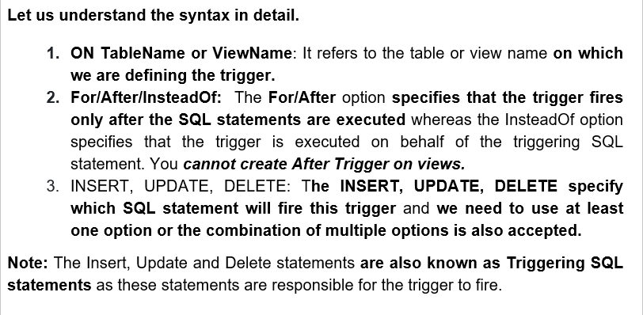

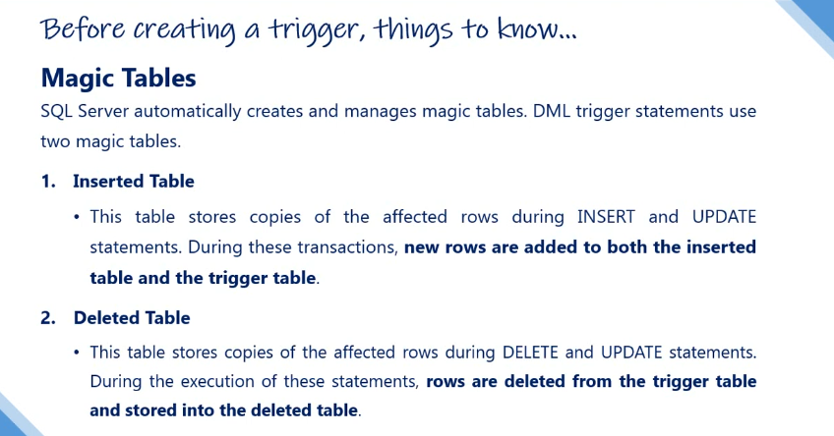

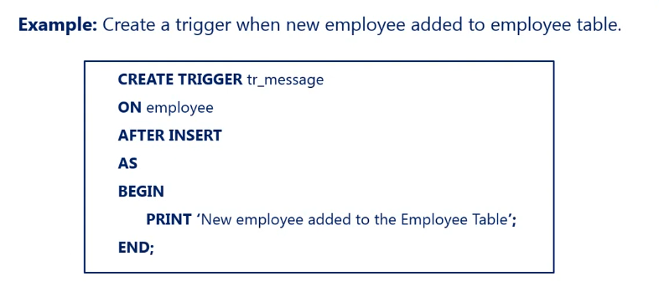

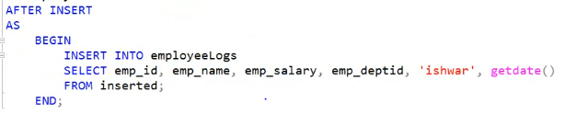

**\*\*\*\*\*\* inserted is a magic table \*\*\*\*\*\*\*\***

**Instead of Trigger**

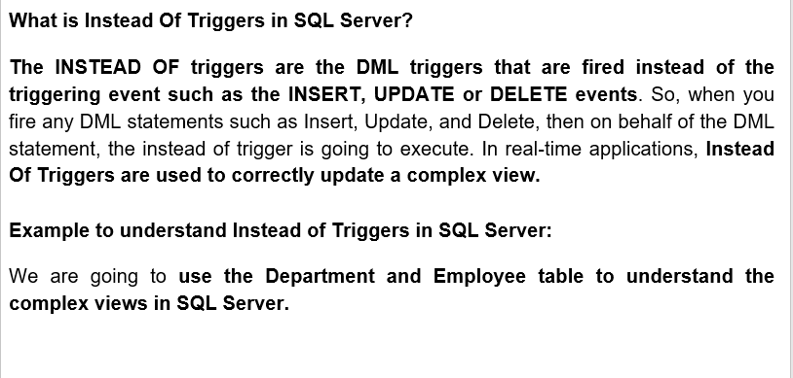

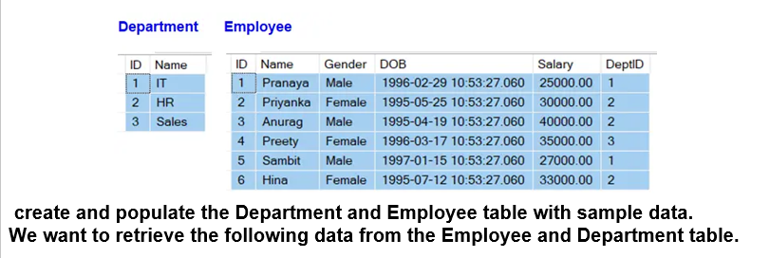

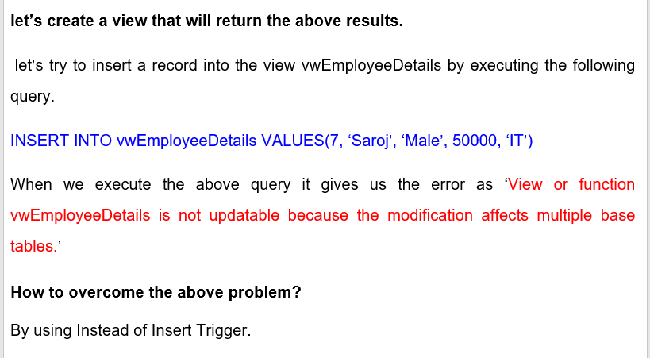

**DDL Trigger**

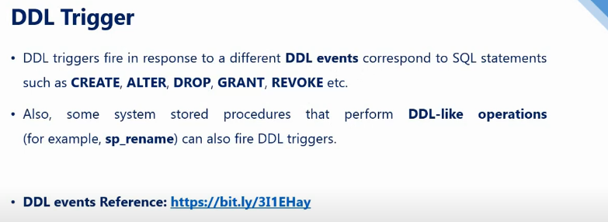

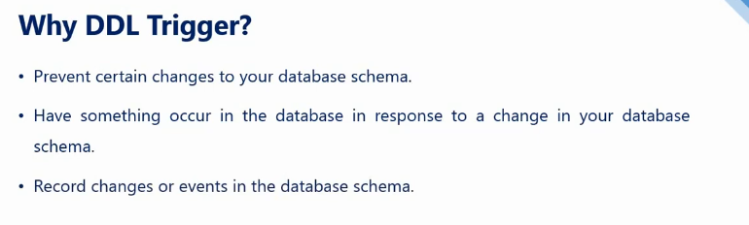

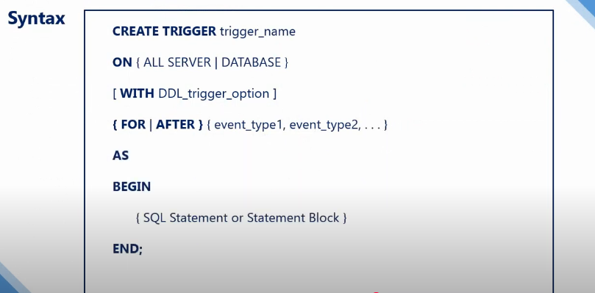

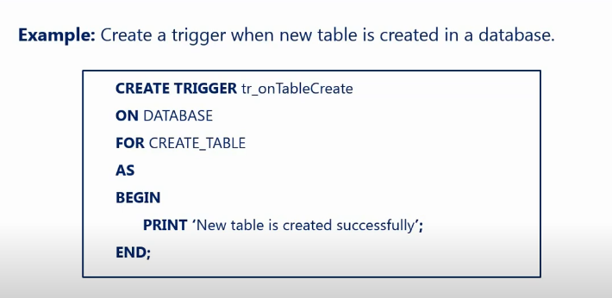

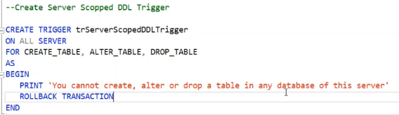

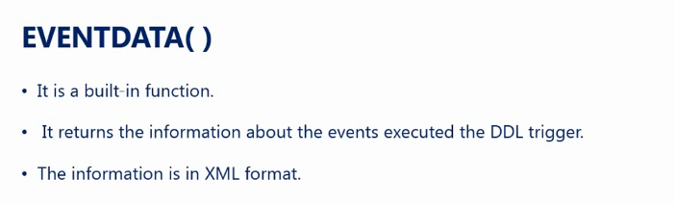

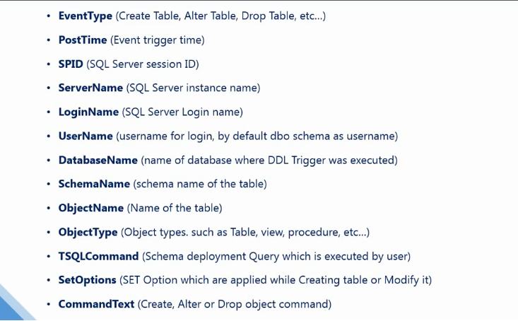

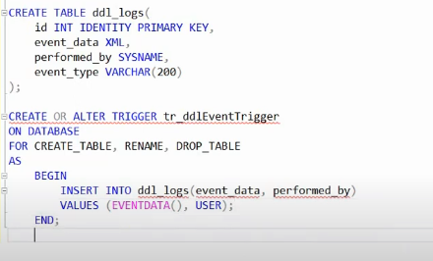

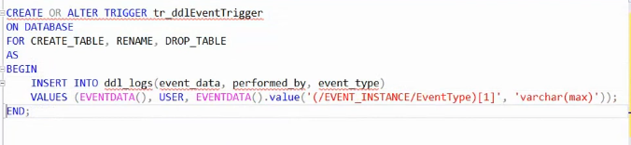

**MERGE Statement in MS SQL Server**

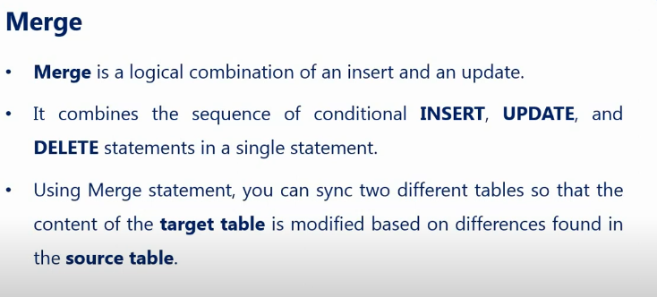

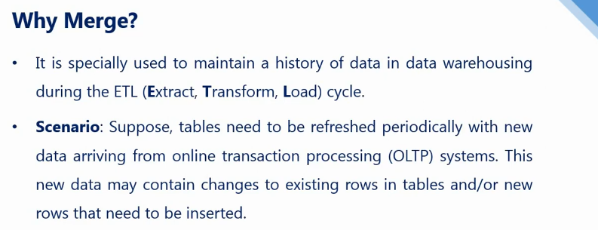

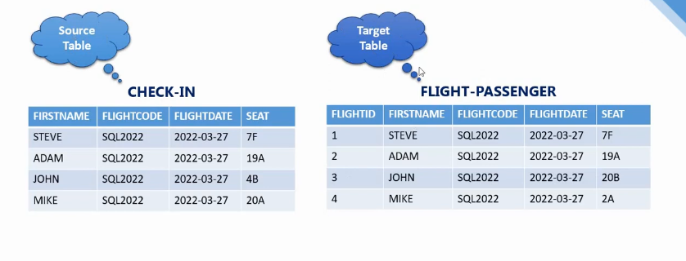

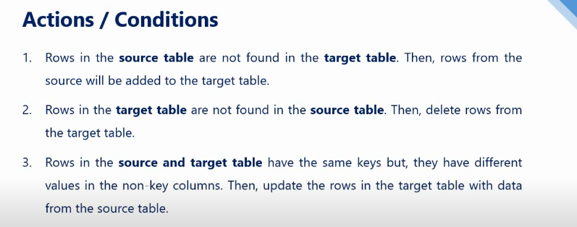

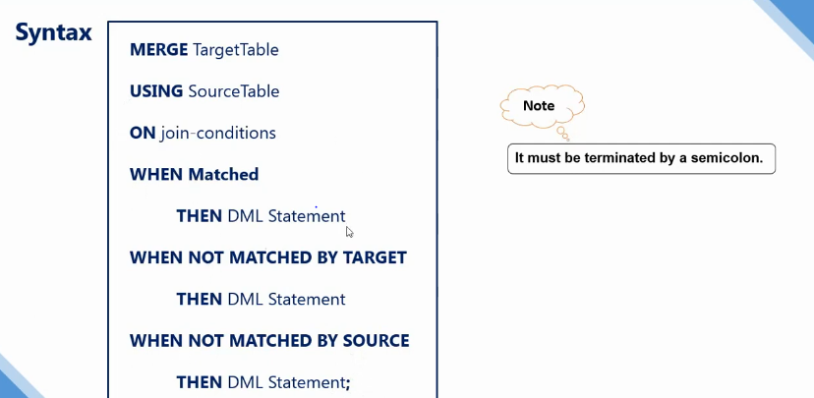

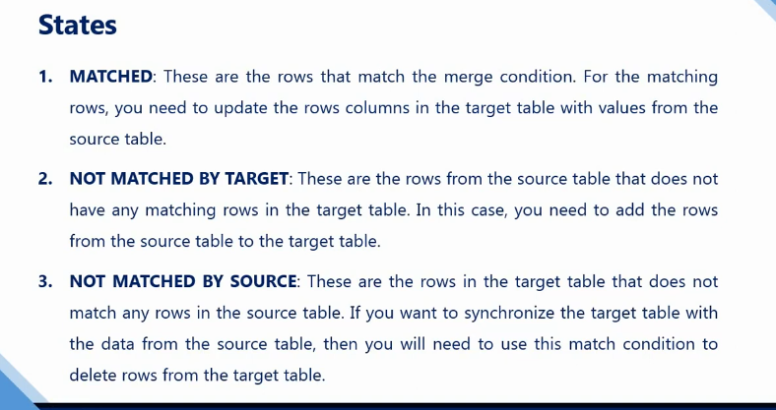

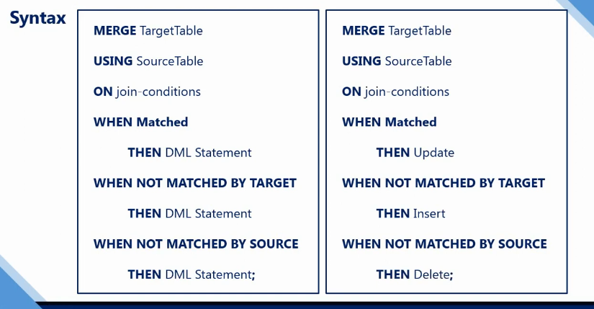

**Example:**

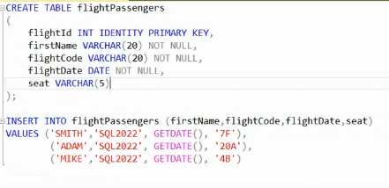

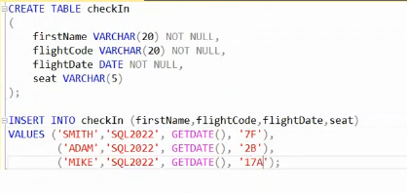

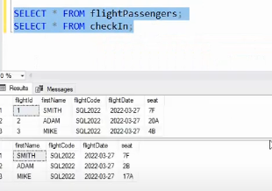

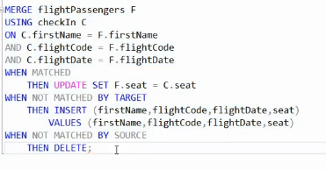

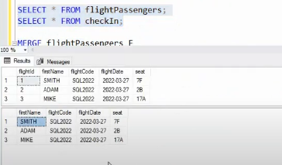

**Introduction to Index in MS SQL Server**

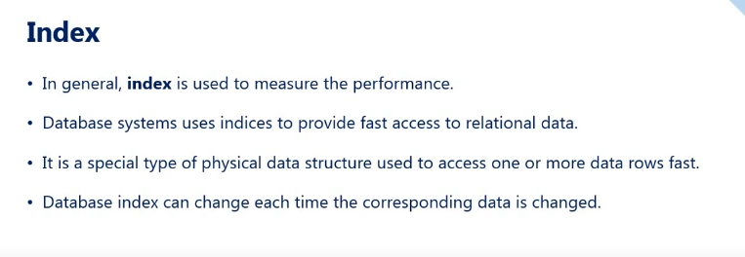

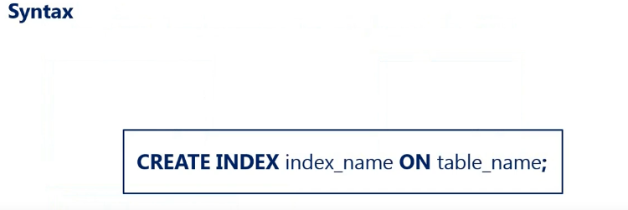

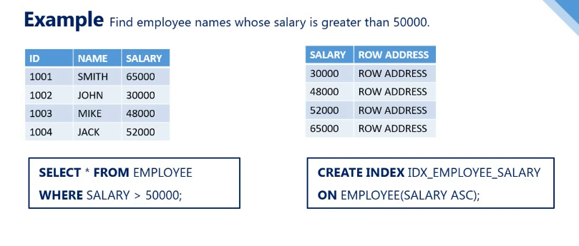

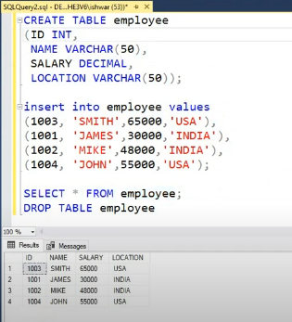

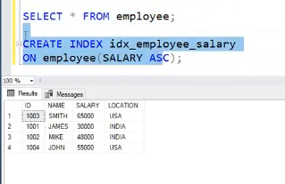

**Clustered Index in MS SQL Server**

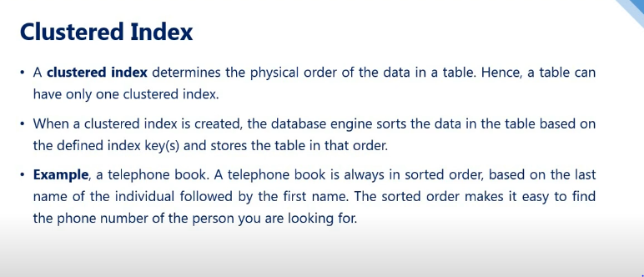

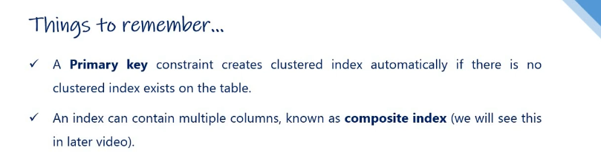

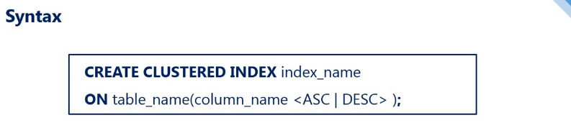

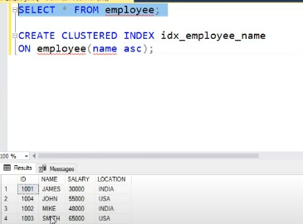

**It sorted row based on name column**

**Composite Clustered INDEX or MULTIPLE Column Clustered Index**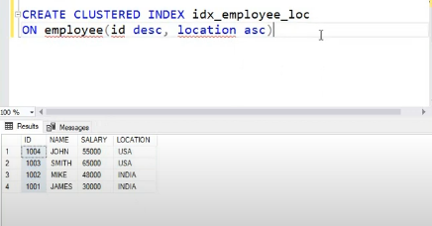

**Nonclustered Index in MS SQL Server**

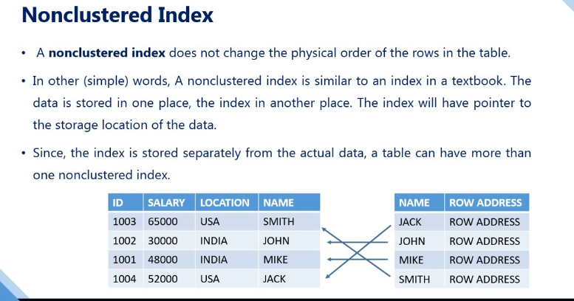

**It helps in access row faster using name column**

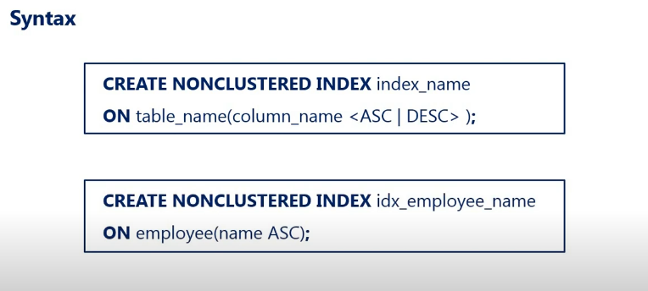

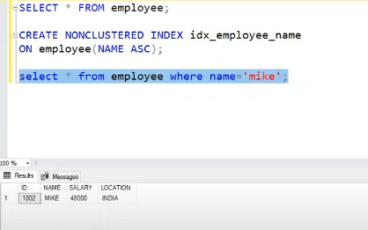

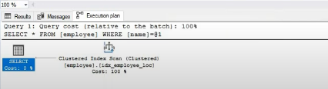

**Unique Index in MS SQL Server**

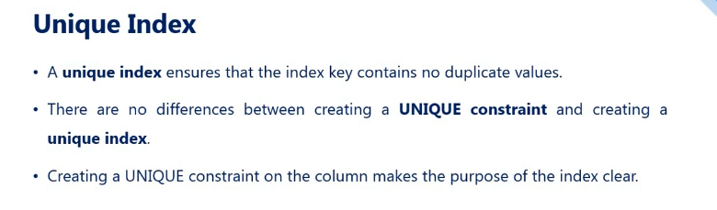

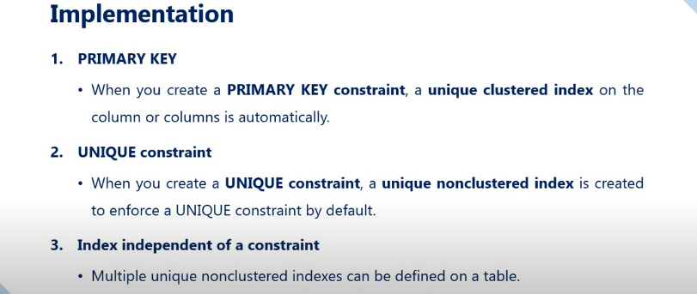

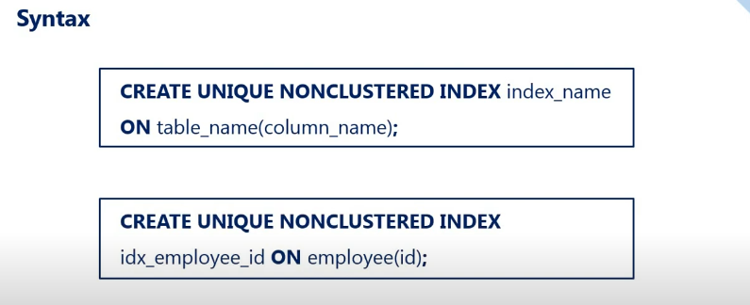

**View in MS SQL Server**

**What is a View in SQL Server?**

**The views in SQL Server are nothing more than a compiled SQL query. We can also consider the Views as virtual tables. As a virtual table, the Views do not store any data physically by default. So when we query a view it actually gets the data from the underlying database tables as shown in the below image.**

**Simply we can say that the views in SQL Server act as an interface between the Table(s) and the user.**

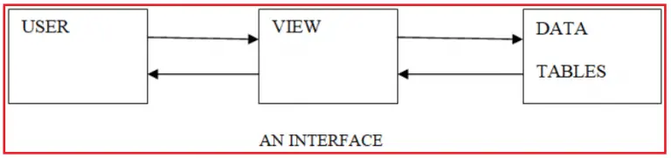

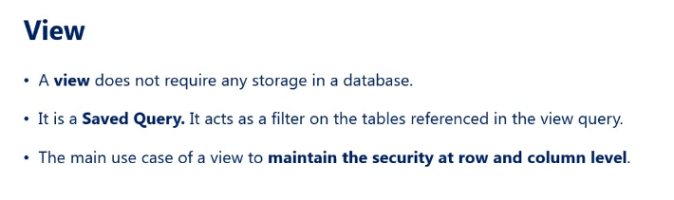

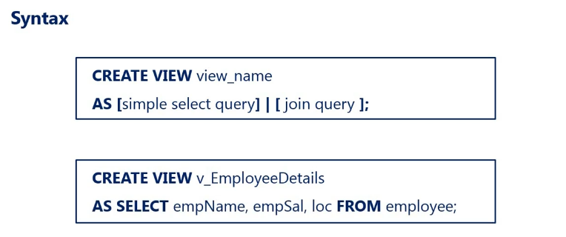

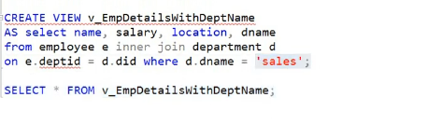

**How many types of views are there in SQL Server?**

**There are two types of views in SQL Server, they are**

1. **Simple Views – single table**
2. **Complex Views – multiple table using joins or other function**

**In simple View, We can insert,update,delete function can be done in VIEW**

**Conclusion:**

1. **In a Complex View, if your update statement affects one base table, then the update succeeded but it may or may not update the data correctly.**
2. **if your update statement affects more than one table, then the update failed and we will get an error message stating “View or function ‘vwEmployeesByDepartment’ is not updatable because the modification affects multiple base tables”.**

**Can we drop a table that has dependent views on it?**

**🡪Yes, you can drop a table even if any dependent views are associated with it, but the views that are associated with it will not be dropped. They will still execute in the database only with the status as inactive object and all those views become active and start functioning provided the table is recreated.**

**Can we create a view based on other views?**

**🡪Yes, It is possible in SQL Server to create a view based on other views.**

**Advantages of Views in SQL Server**

**We are getting the following advantages of using Views in SQL Server.**

1. **Hiding the complexity**
2. **Implementing Row and Column Level Security.**
3. **Presenting the aggregated data by hiding the detailed data.**

**CTE in MS SQL Server**

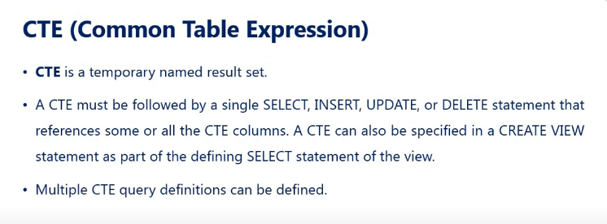

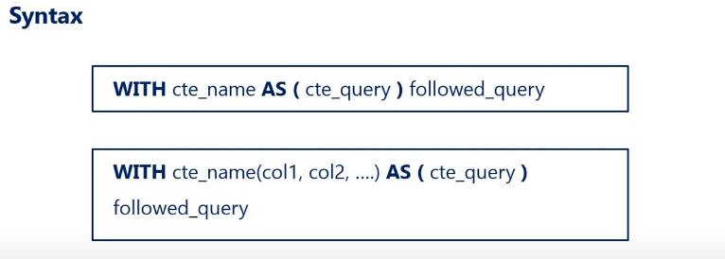

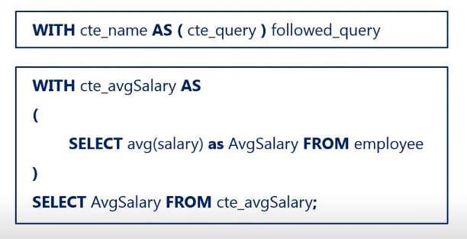

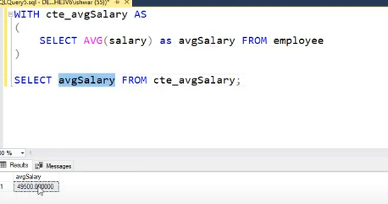

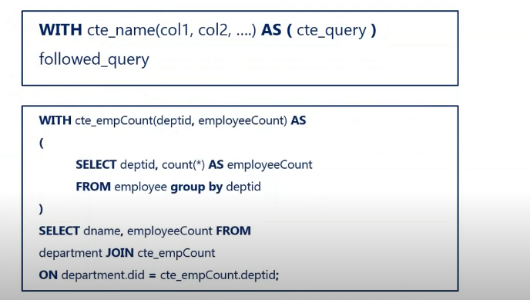

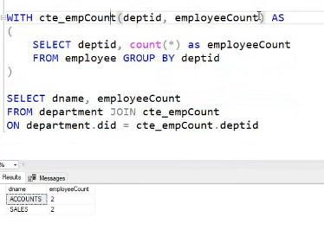

**TCL (Commit, Rollback, Save)**

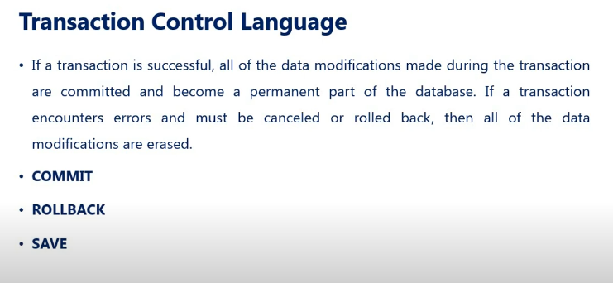

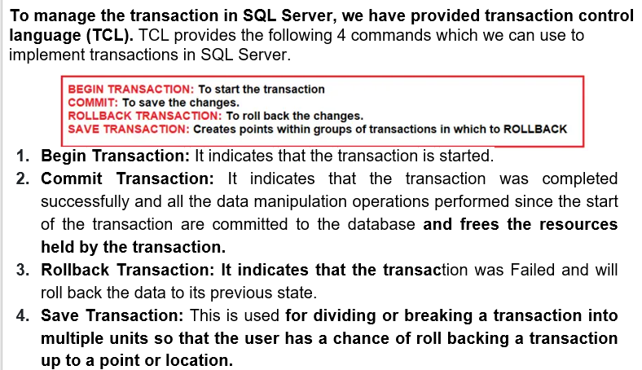

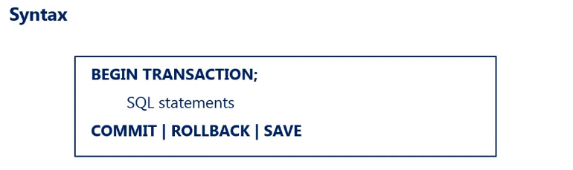

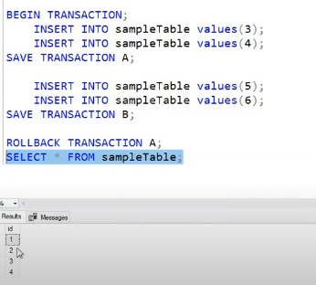

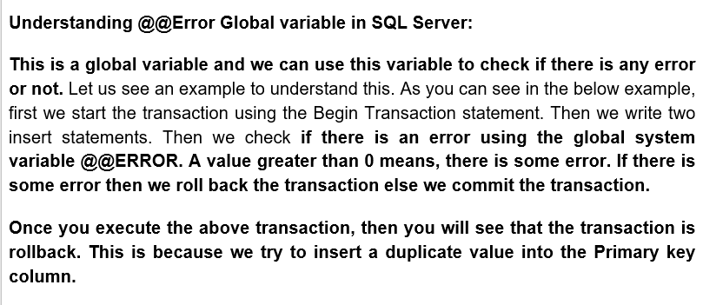

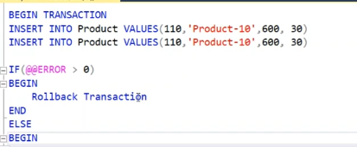

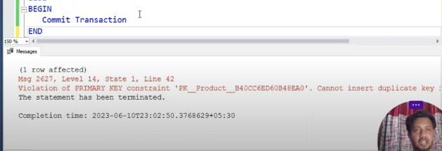

**Types of Transactions in SQL Server:**

**The SQL Server Transactions are classified into three types, they are as follows**

1. **Auto Commit Transaction Mode (default)**

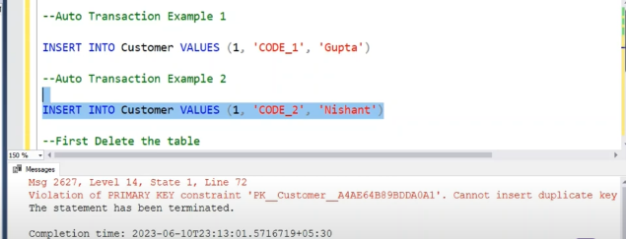

1. **Implicit Transaction Mode – Need specific command to like commit or rollback**

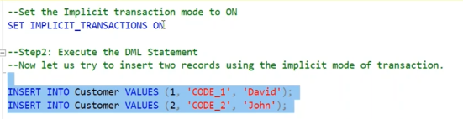

**COMMIT TRANSACTION or ROLLBACK**

1. **Explicit Transaction Mode – Similar to normal TCL using begin and end**



**Backup and Restore Database in MS SQL Server.**

**Using Microsoft SQL Server 2019**

**ACID Properties in SQL Server**

**In the context of transaction processing, the acronym ACID refers to the four key properties of a transaction, such as**

1. **Atomicity**

**ensures that either all the DML Statements (i.e. insert, update, delete) inside a transaction are completed successfully or all of them are rolled back.**

1. **Consistency**

**ensures that the database data is in a consistent state before the transaction started and also left the data in a consistent state after the transaction is completed. If the transaction violates the rules then it should be rolled back. For example, if stocks available are decremented from the Product table then there has to be a related entry in the ProductSales table**

**ANOTHER EXAMPLE:BANK TRANSACTION detected from one account and added on other account**

1. **Isolation**

**ensures that the intermediate state of a transaction is invisible to other transactions. The Data modifications made by one transaction must be isolated from the data modifications made by all other transactions. Most databases use locking to maintain transaction isolation.**

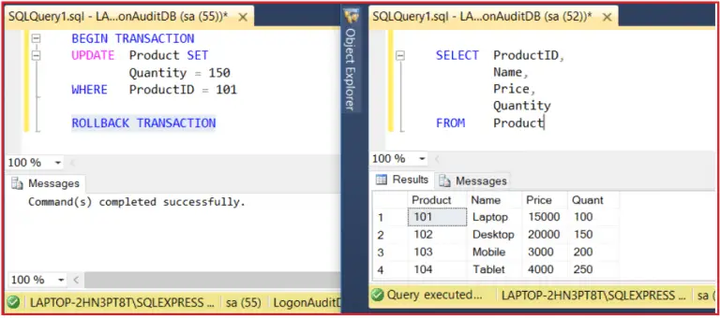

1. **Durability.**

**ensures that once the transaction is successfully completed, then the changes it made to the database will be permanent. Even if there is a system failure or power failure or any abnormal changes, it should safeguard the committed data.**

**Concurrency in SQL Server**

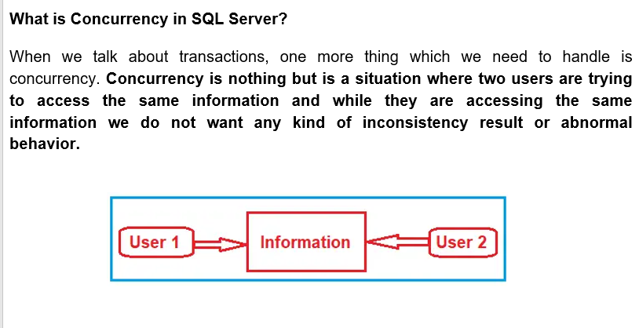

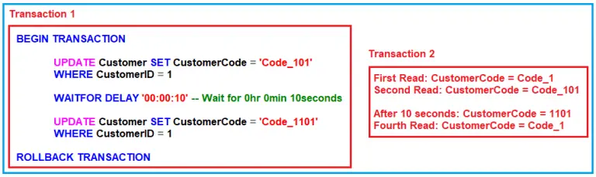

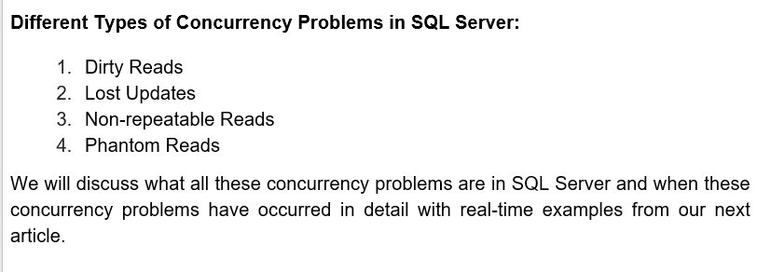

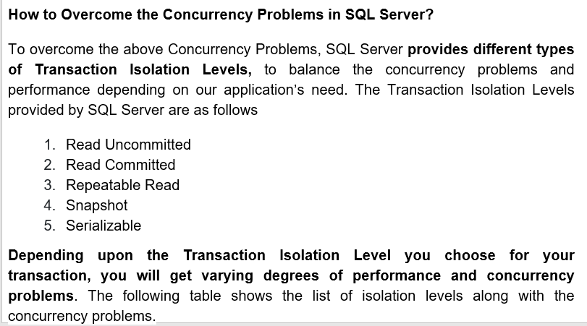

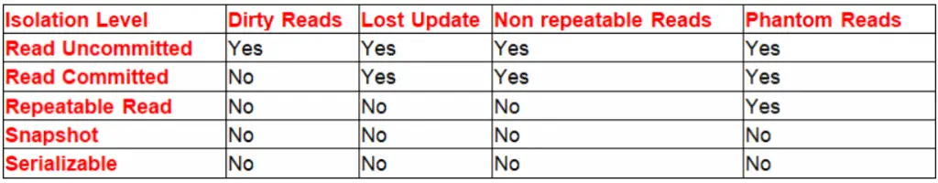

**Dirty Read Concurrency Problem in SQL Server**

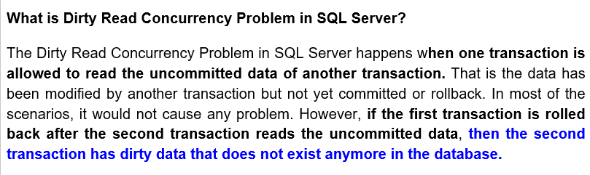

Example :

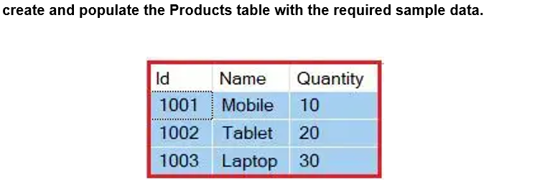

Transaction 1:

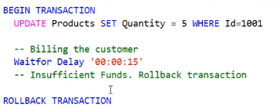

Transaction 2:

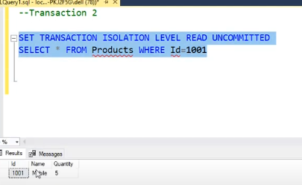

**How to Overcome the Dirty Read Concurrency Problem Example in SQL Server?**

**If you want to restrict the dirty read concurrency problem in SQL Server, then you have to use any Transaction Isolation Level except the Read Uncommitted Transaction Isolation Level.** So,

modify transaction 2 as shown below and hear we are using Read Committed Transaction Isolation Level

Transaction 1:



Transaction 2:

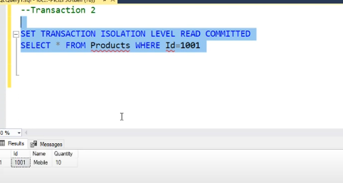

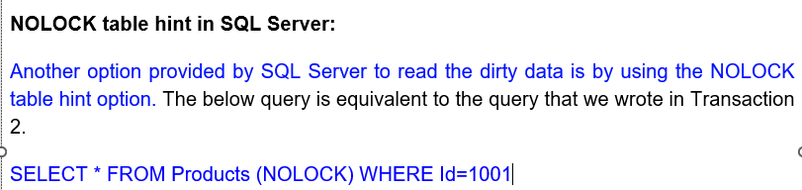

**Lost Update Concurrency Problem in SQL Server**

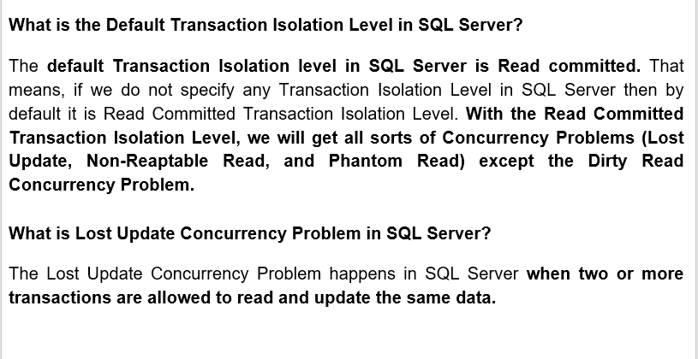

Example:

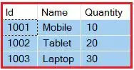

Transaction 1:

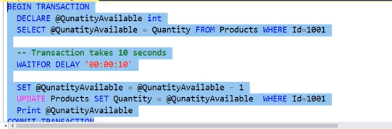

Transaction 2:

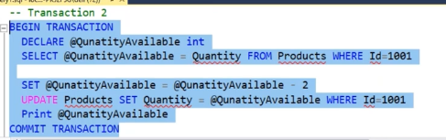

Table:

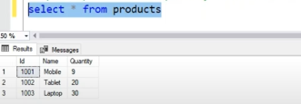

**How to Overcome the Lost Update Concurrency Problem?**

Both **Read Uncommitted and Read Committed Transaction Isolation Levels have the Lost Update Concurrency Problem**. The other Isolation Levels such as **Repeatable Read, Snapshot, and Serializable do not have the Lost Update Concurrency Problem**. So, if we run the above Transactions using any of the higher Transaction Isolation Levels such as Repeatable Read, Snapshot, or Serializable, then we will not get the lost update concurrency problem.

Transaction 1:



Transaction 2:

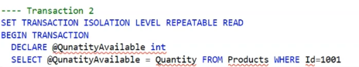

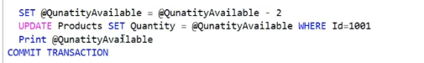

Table:

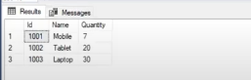

**Non-Repeatable Read Concurrency**

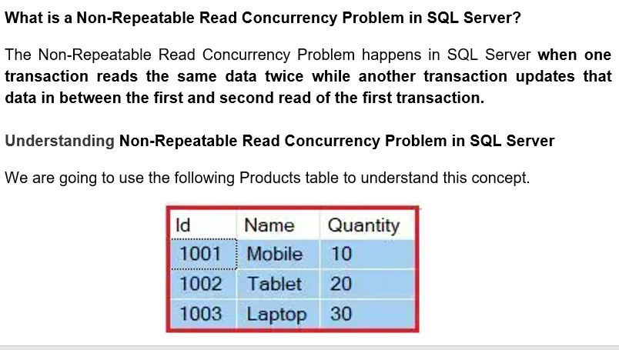

Example:

**Transaction 1**

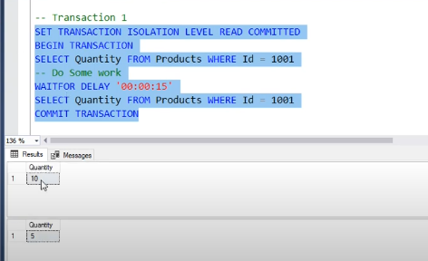

**Transaction 2**

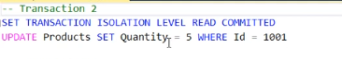

**How to Solve the Non-Repeatable Read Concurrency Problem in SQL Server?**

In order to solve the Non-Repeatable Read Problem in SQL Server, **we need to use either Repeatable Read Transaction Isolation Level or any other higher isolation level such as Snapshot or Serializable**. So, let us s**et the transaction isolation level of both Transactions to repeatable read** (you can also use any higher transaction isolation level). **This will ensure that the data that Transaction 1 has read will be prevented from being updated or deleted elsewhere. This solves the non-repeatable read concurrency issue.** Let us rewrite both the transactions using the Repeatable Read Transaction Isolation Level.

**Modify the Transactions**

**Transaction 1**

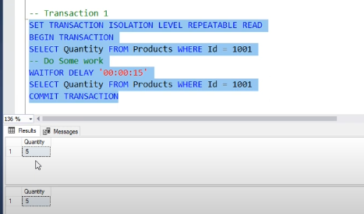

**Transaction 2**

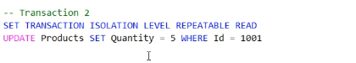

**Phantom Read Concurrency**

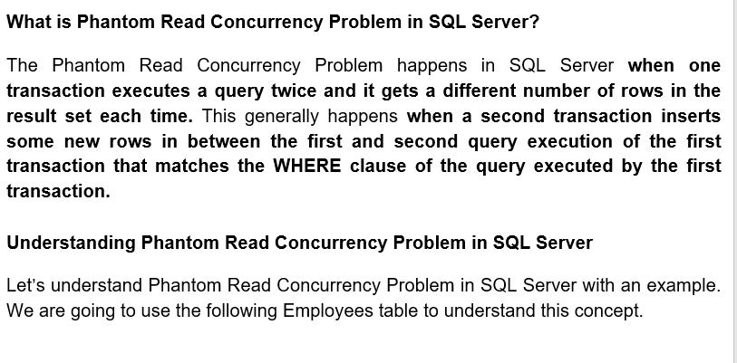

**Phantom Read Concurrency Problem in SQL Server with an Example:**

**Transaction 1**

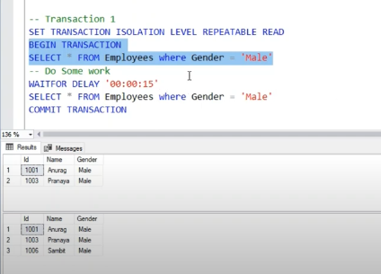

**Transaction 2**

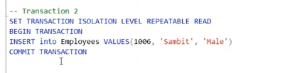

**How to solve the Phantom Read Concurrency Problem in SQL Server?**

You can use the Serializable or Snapshot Transaction Isolation Level to solve the Phantom Read Concurrency Problem in SQL Server.

**Transaction 1**

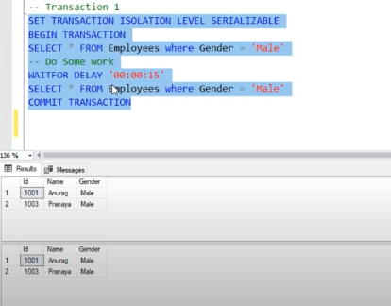

**Transaction 2**

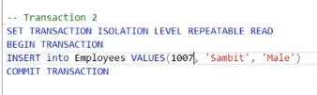

**Deadlock in SQL Server**

**When a deadlock occurs in SQL Server?**

A deadlock occurs in a database **when two or more processes have already a resource locked, and then each process wants to acquire a lock on the resource that the other process has already locked**. In such cases, **neither of the processes can move forward, as each process is waiting for the other process to release the lock** **resulting in a deadlock in SQL Server**. If you are confused, then just have a look at the following diagram which explains the above points i.e. when a deadlock occurs in a database.

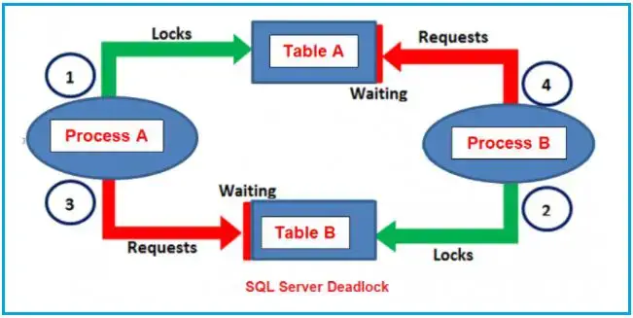

Understanding Deadlock in SQL Server with Examples.

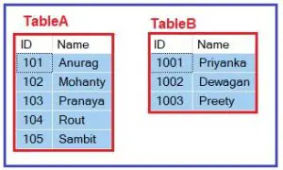

Tranaction 1;

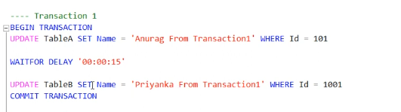

Tranaction 2:

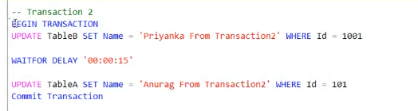 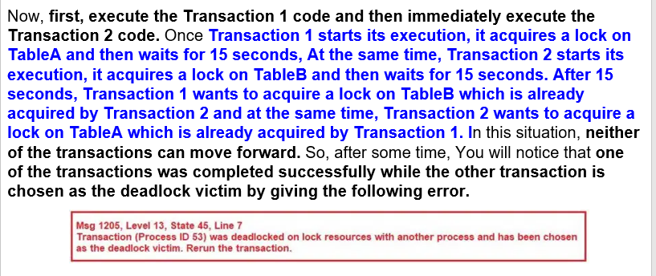

**How Deadlocks are detected by SQL Server?**

The **Lock Monitor thread of SQL Server by default runs in every 5 seconds to detect if there are any deadlocks occurred in the database.** If the Lock Monitor thread finds any deadlocks in the database, then the deadlock **detection interval will be a drop from 5 seconds to as low as 100 milliseconds depending on the frequency of the deadlocks**. If the Lock Monitor thread stops finding deadlocks, then the Database Engine increases the intervals to 5 seconds.

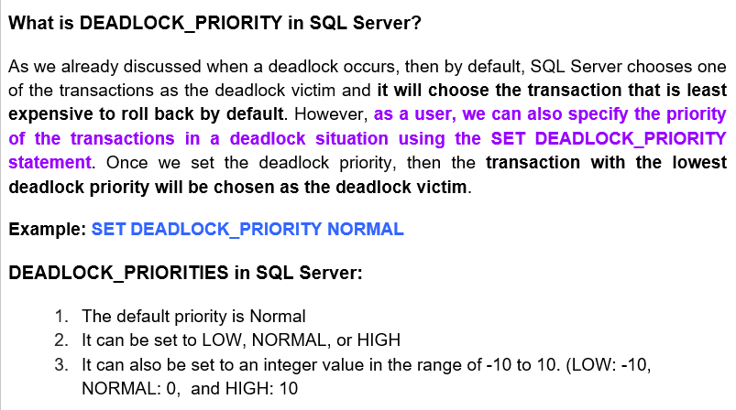

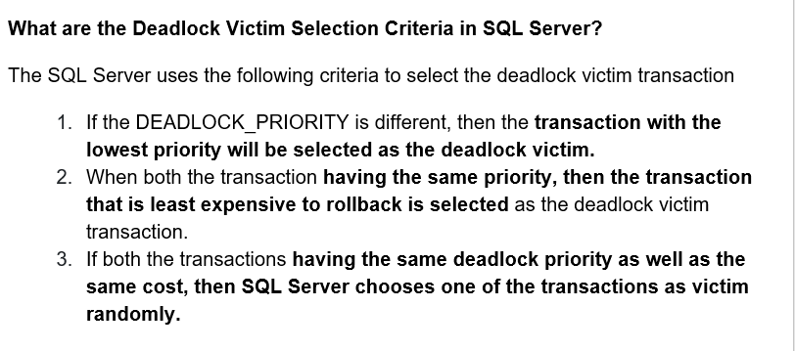

**Deadlock Logging in SQL Server**

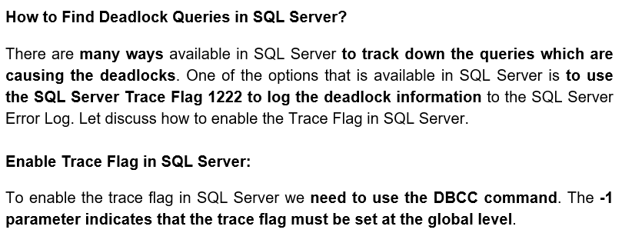

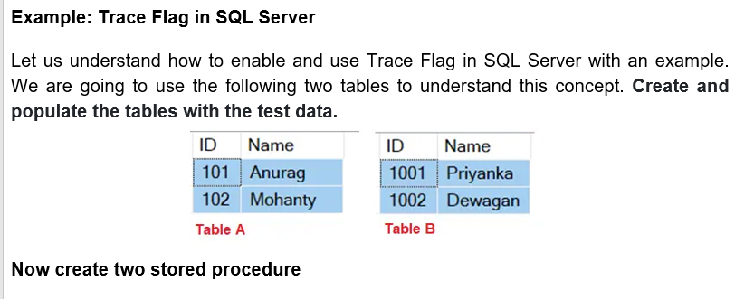

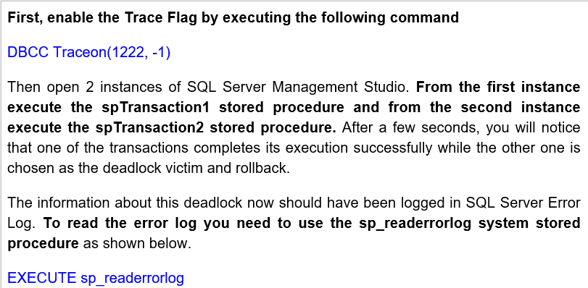

**To prevent the deadlock that we have in our example, we need to ensure that the database objects such as Table A & Table B are accessed in the same order every time.**

**Normalization:**

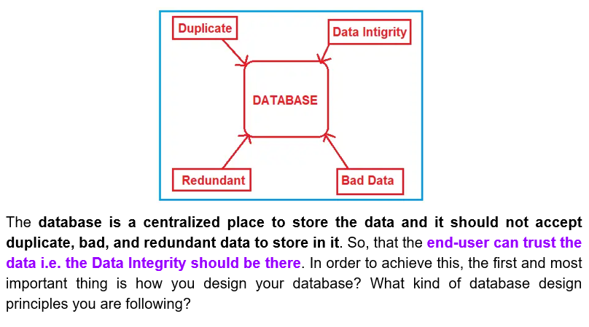

DESIGN MISTAKE 1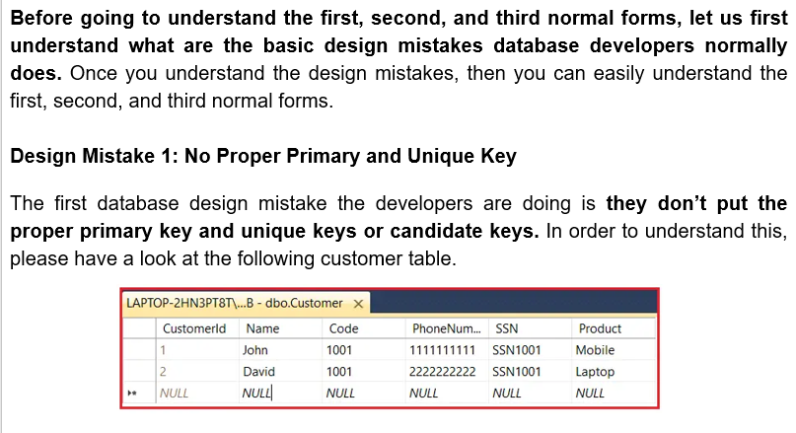

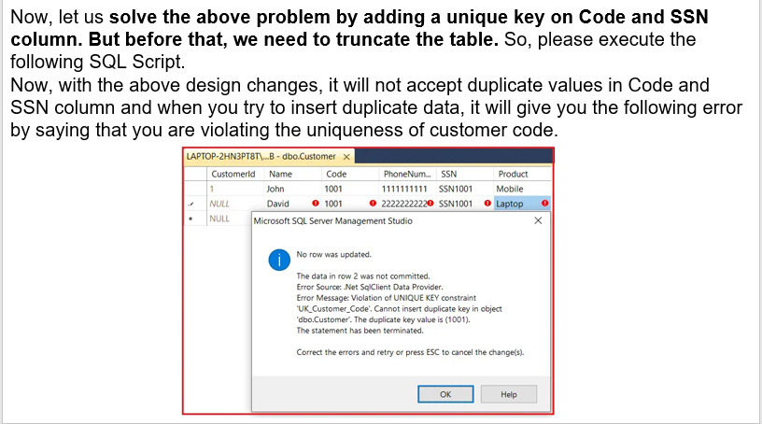

DESIGN MISTAKE 2

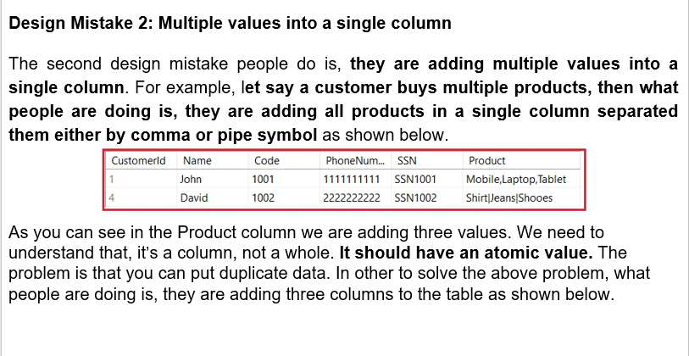

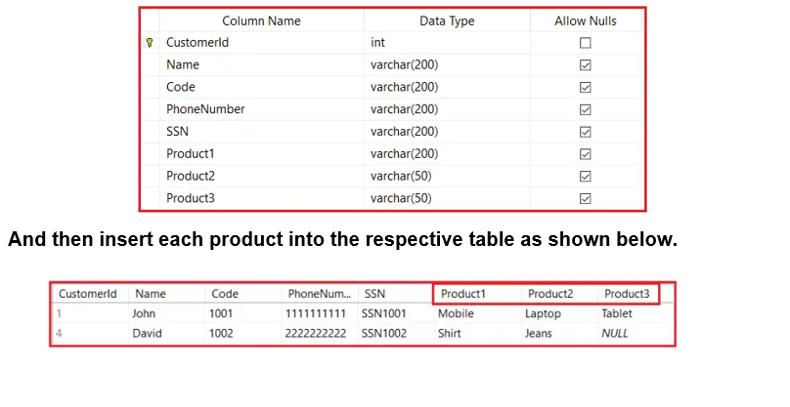

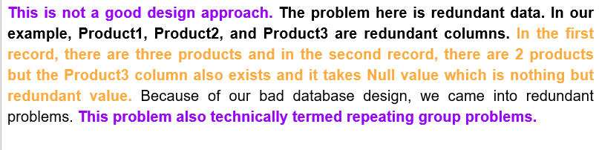

DESIGN MISTAKE 3

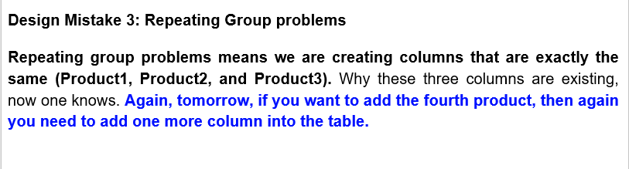

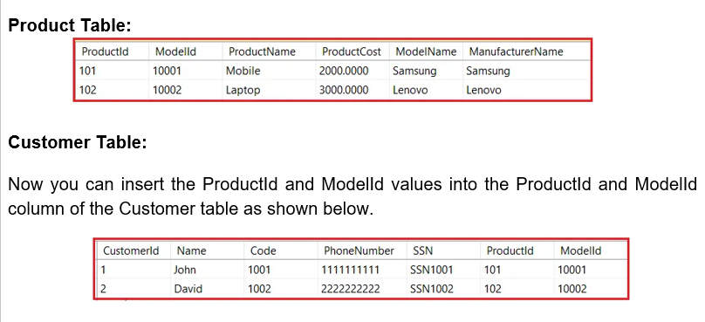

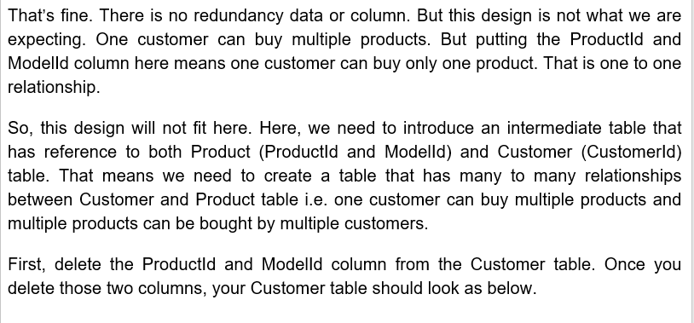 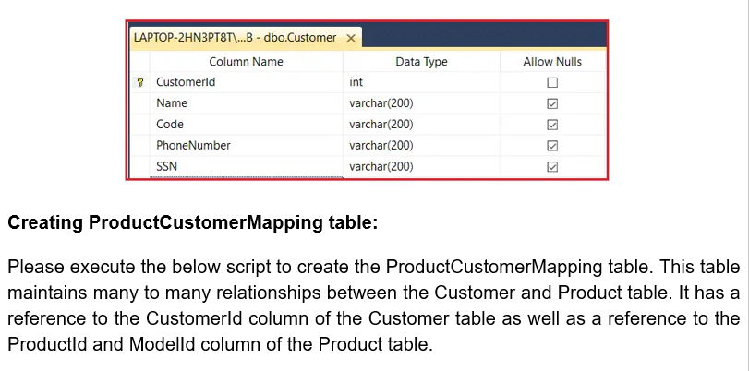

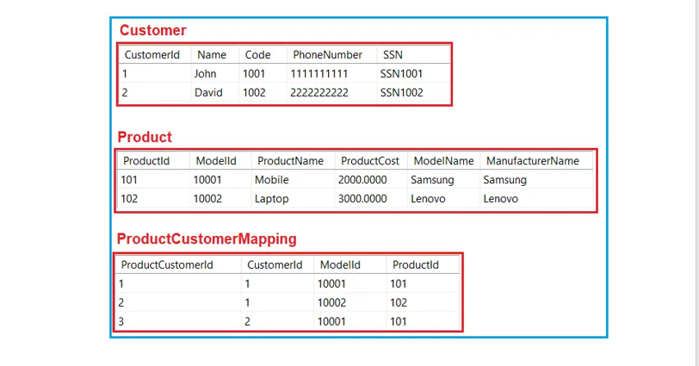

**First Normal Form in Database Normalization**

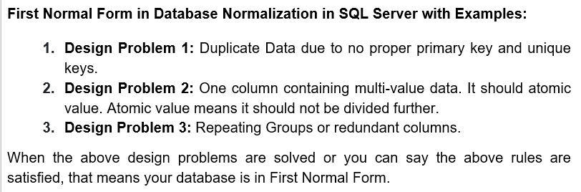

DESIGN PROBLEM 4: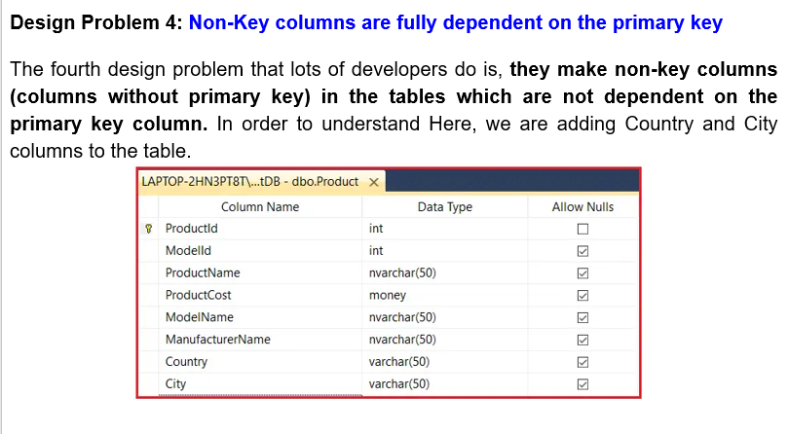

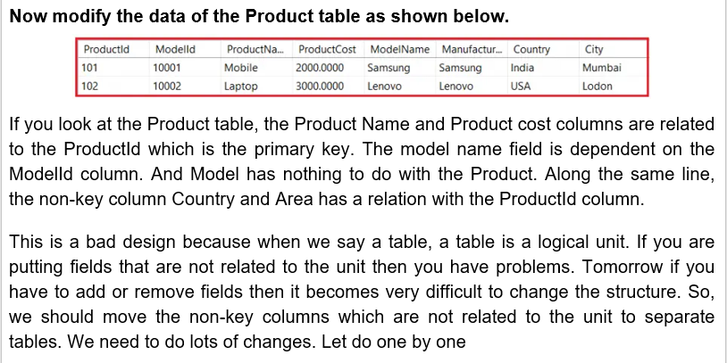

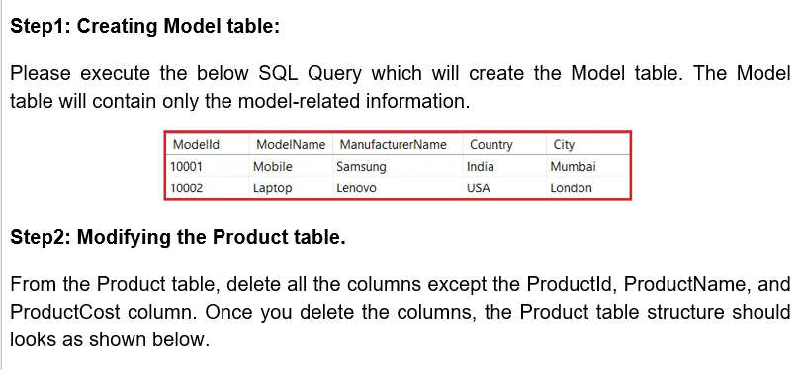

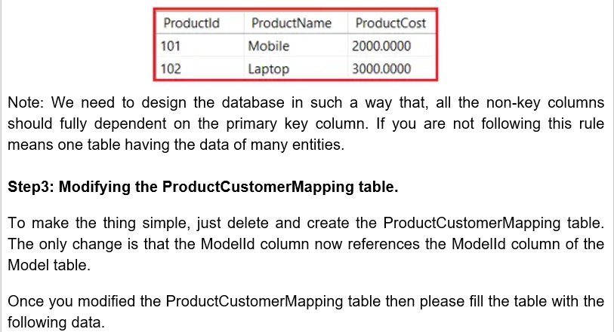

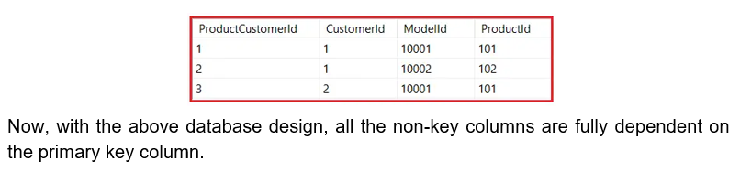

**Second Normal Form in Database Normalization**

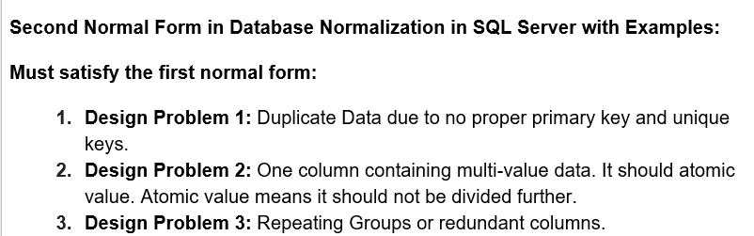

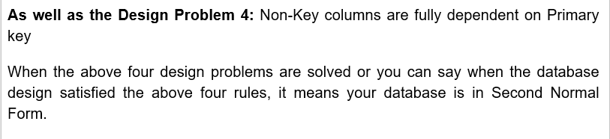

DESIGN PROBLEM 5:

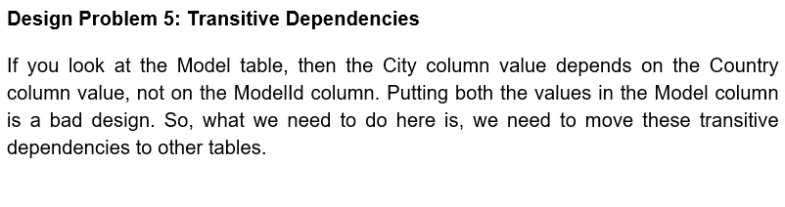

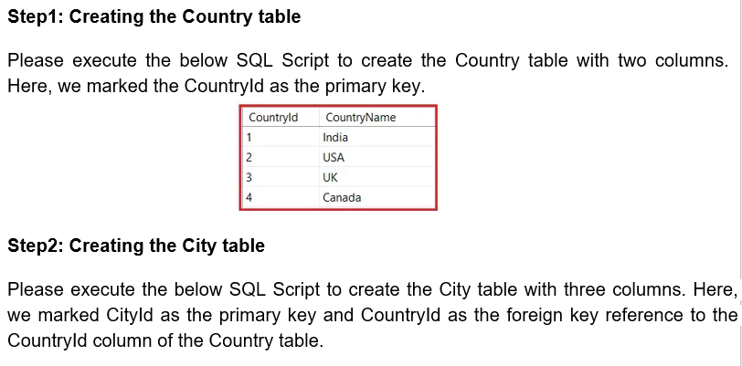

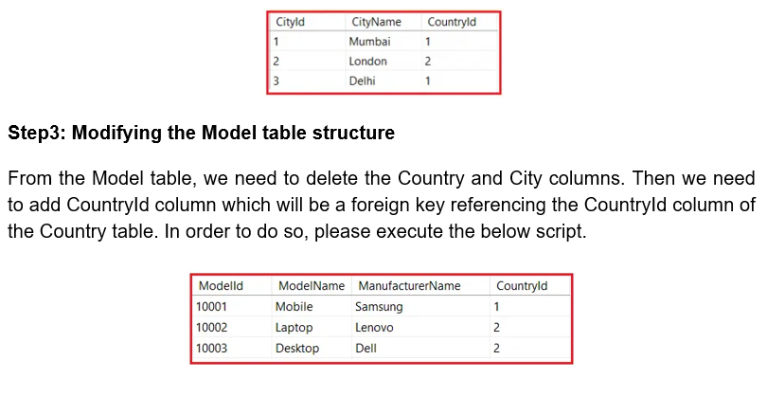

**Third Normal Form in Database Normalization**

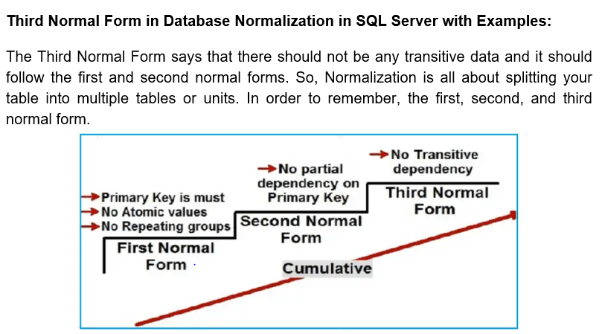

**De-Normalization**

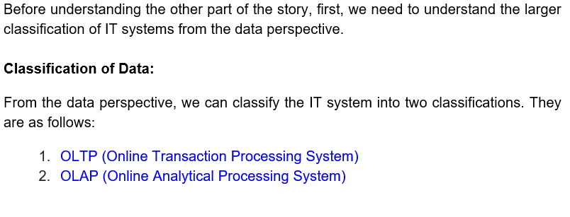

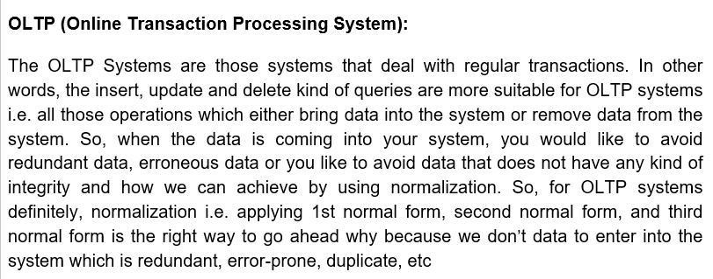

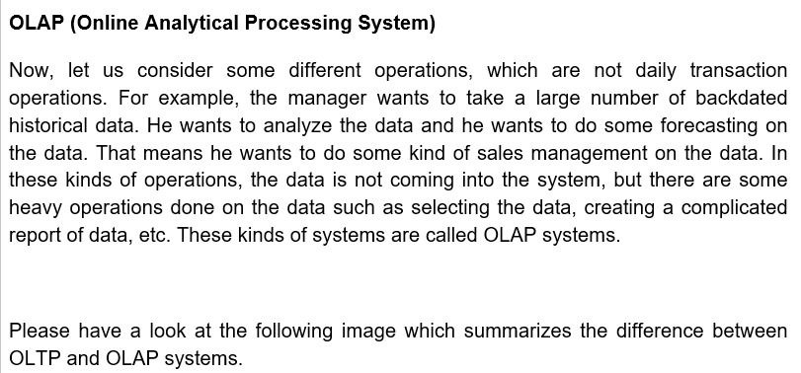

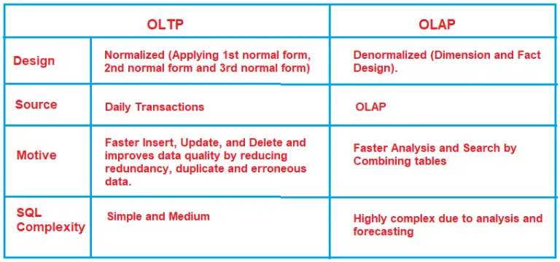

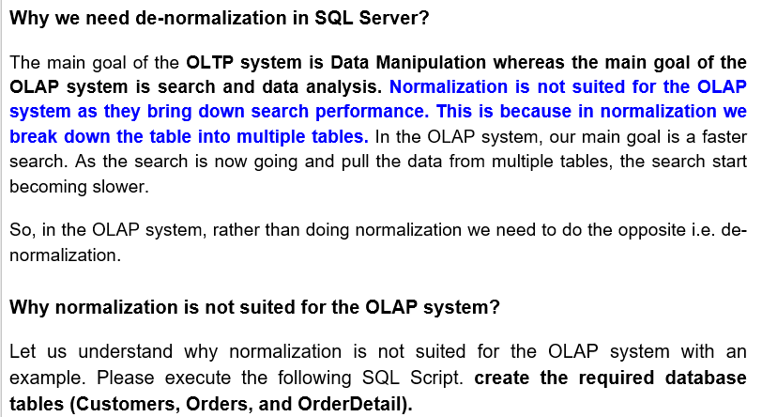

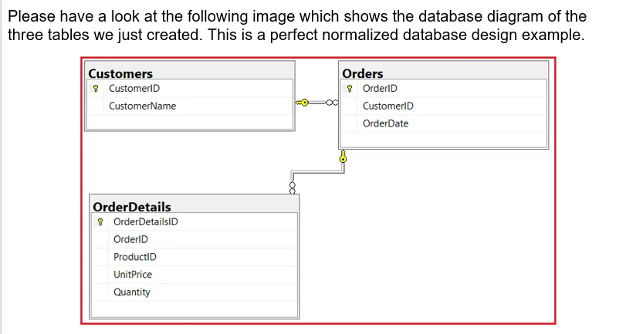

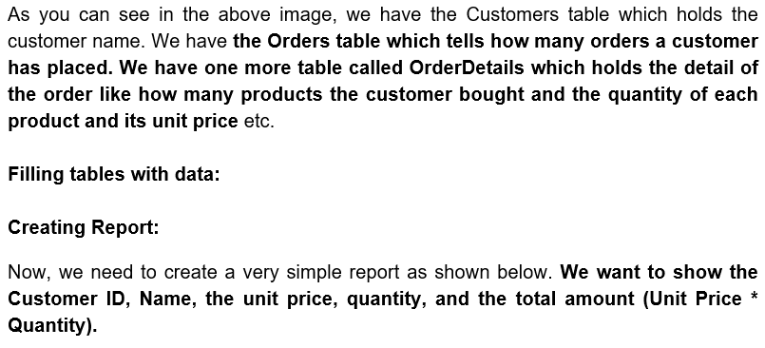

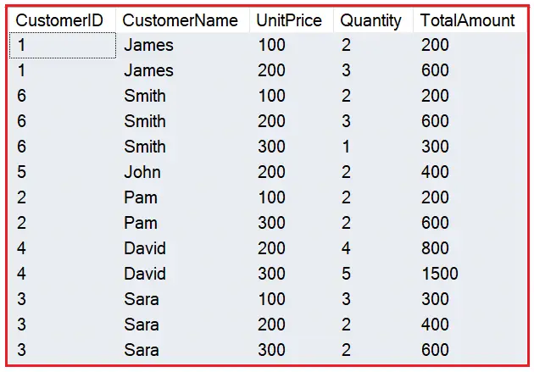

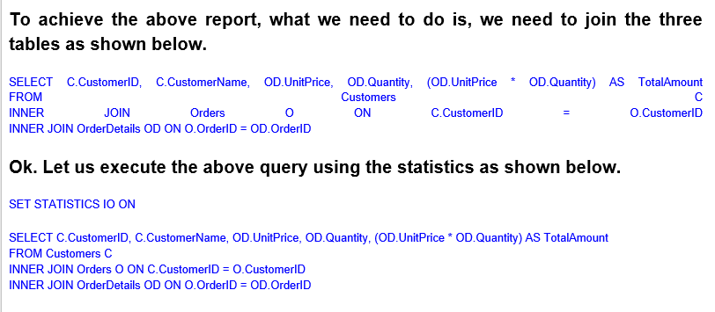

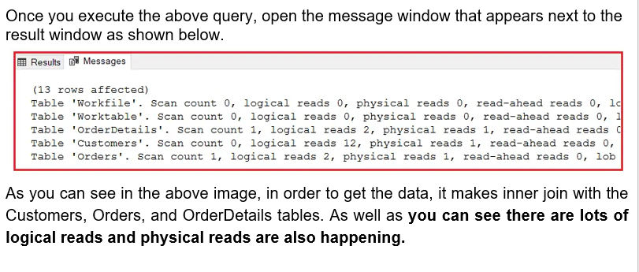 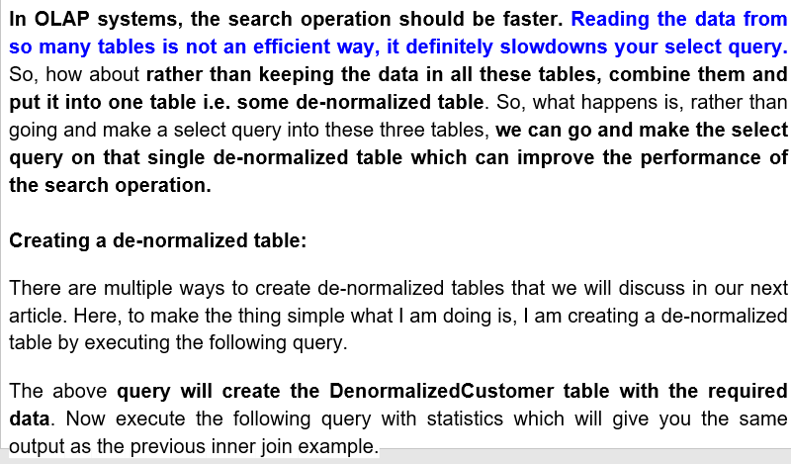

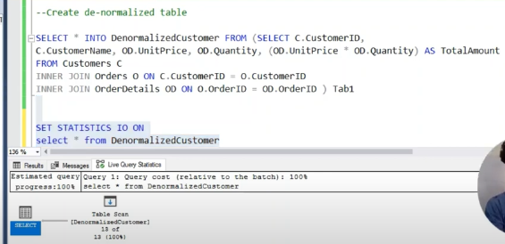

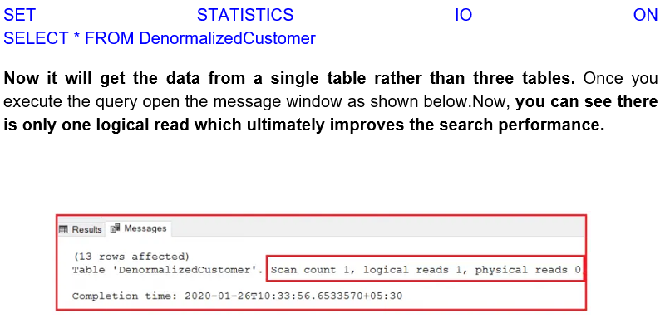

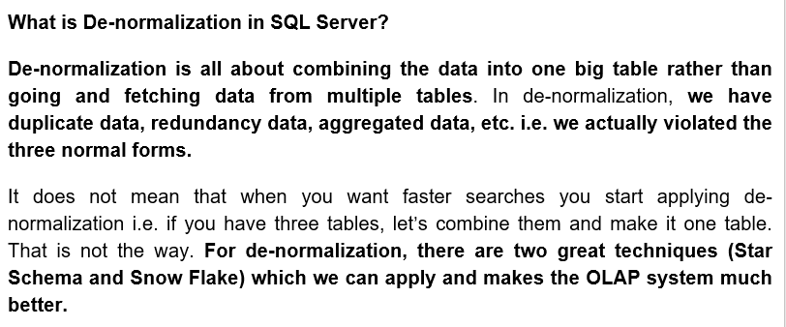

**Pivot and Unpivot Table in SQL Server**

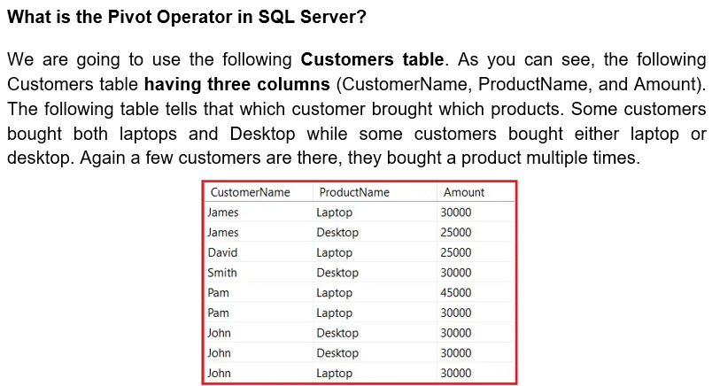

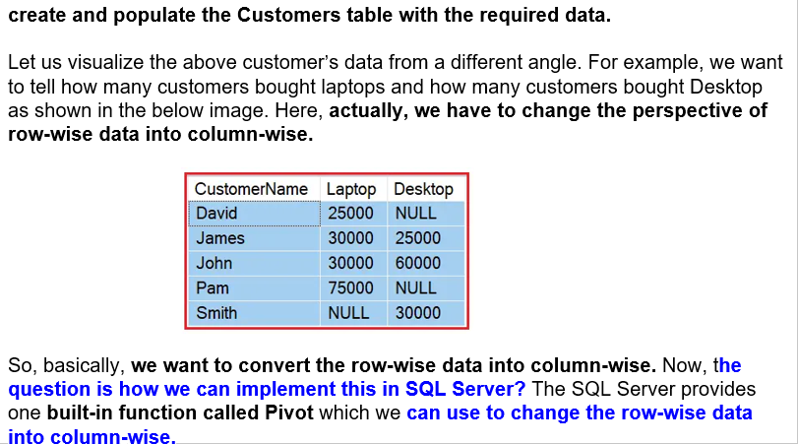

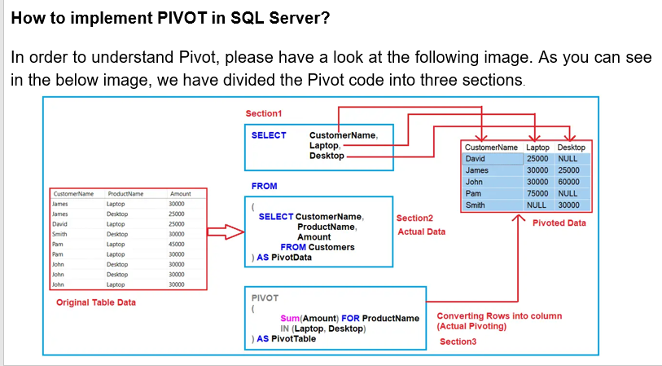

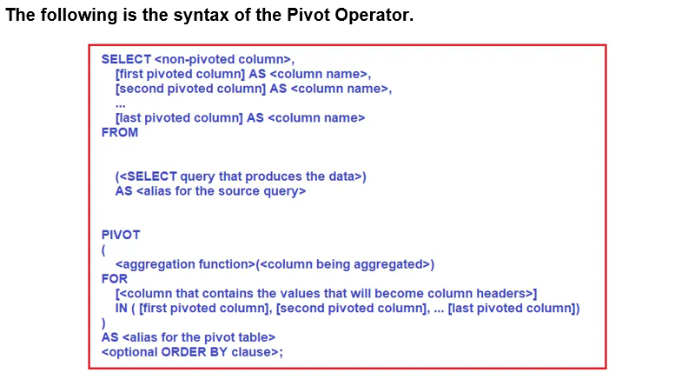

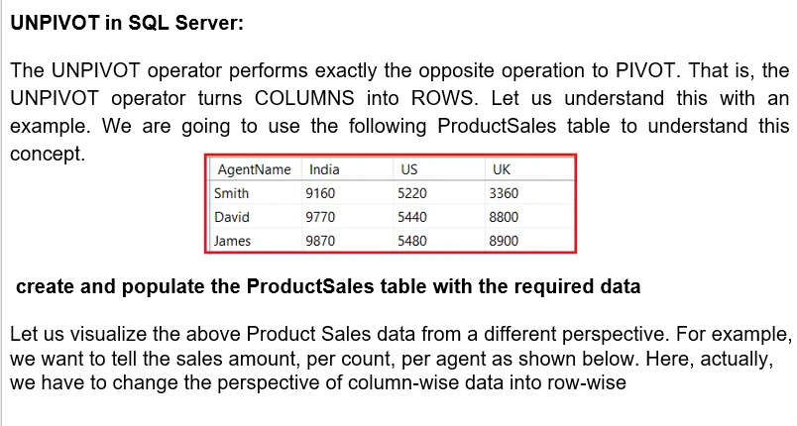

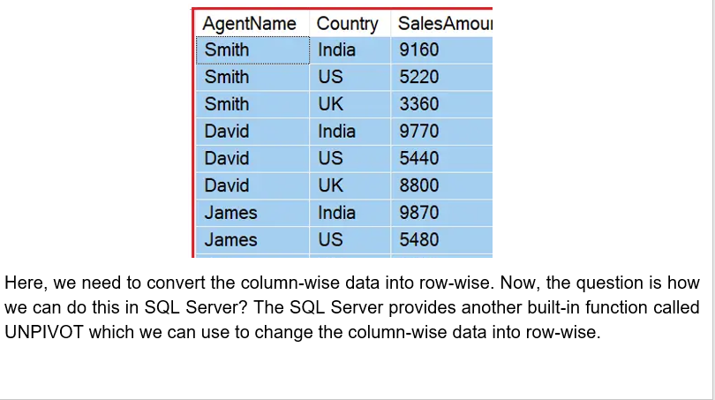

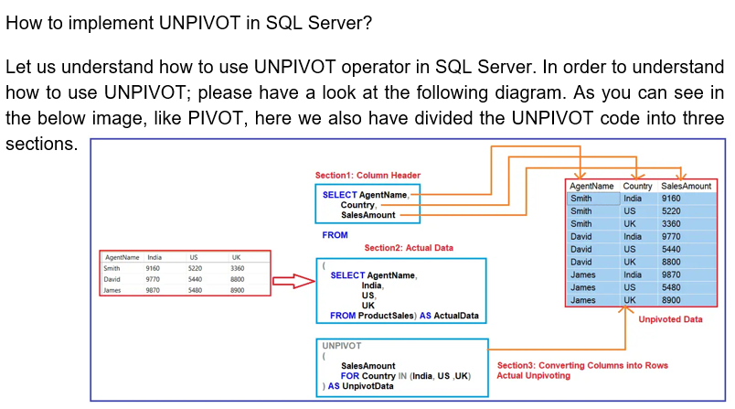

**Reverse Pivot Table**

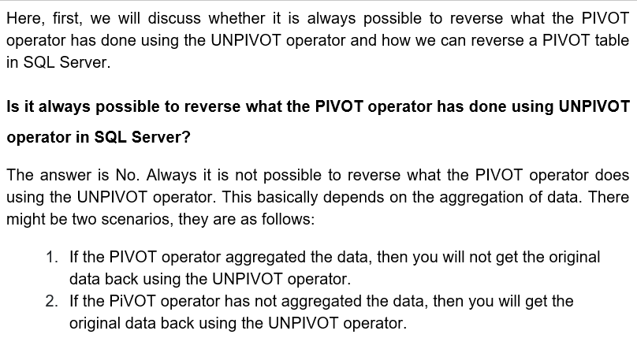

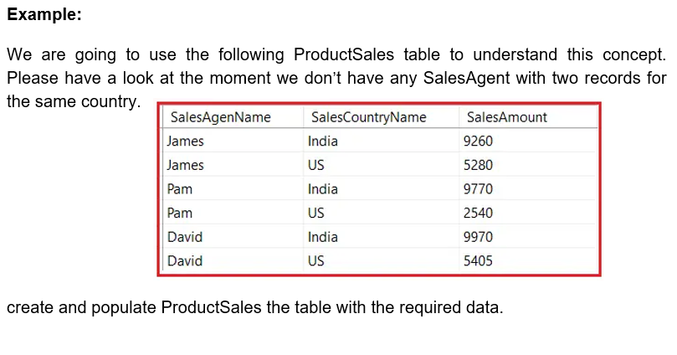

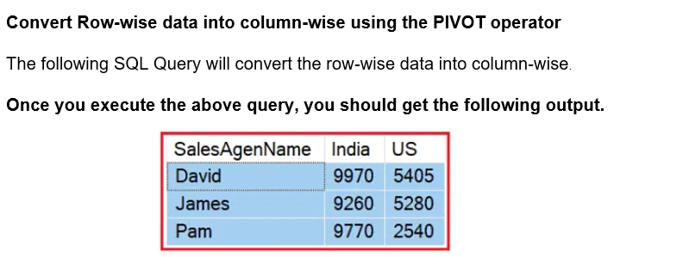

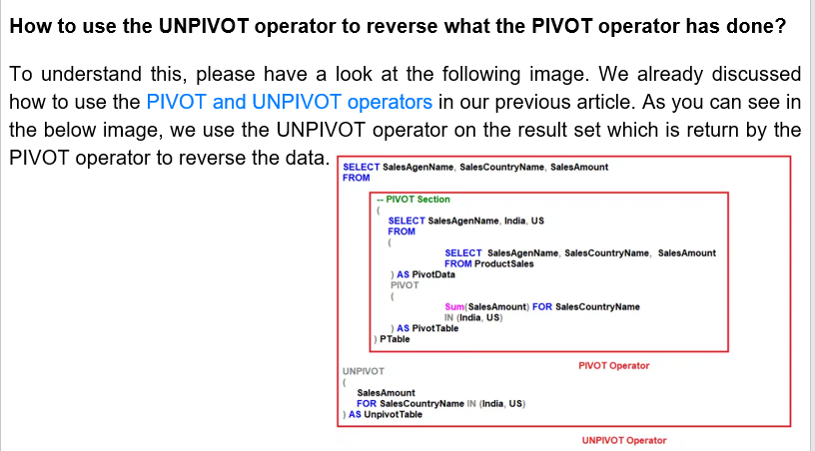

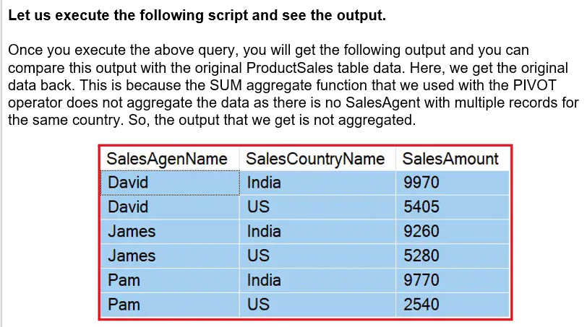

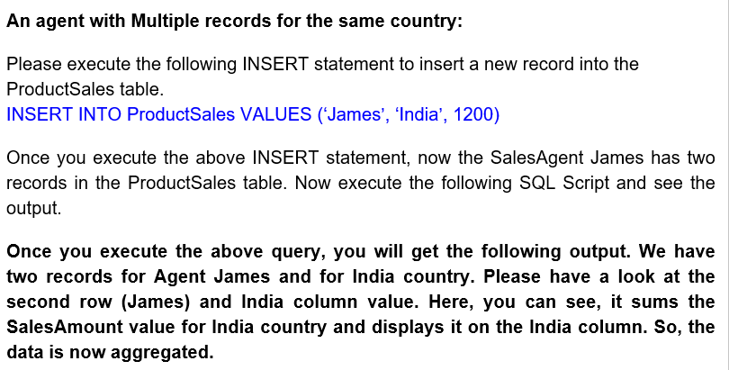

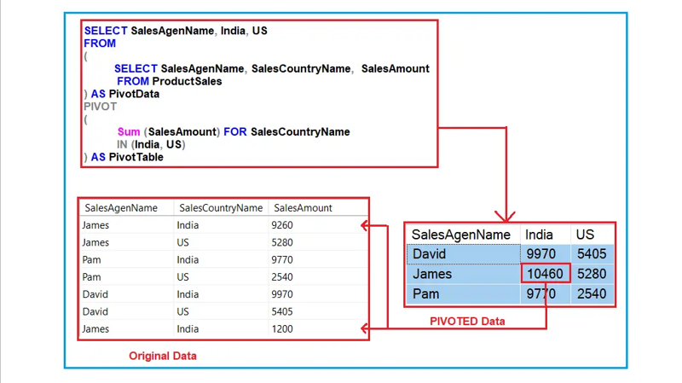

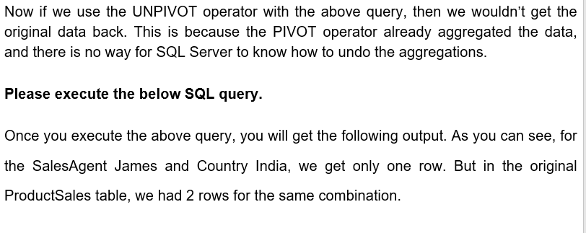

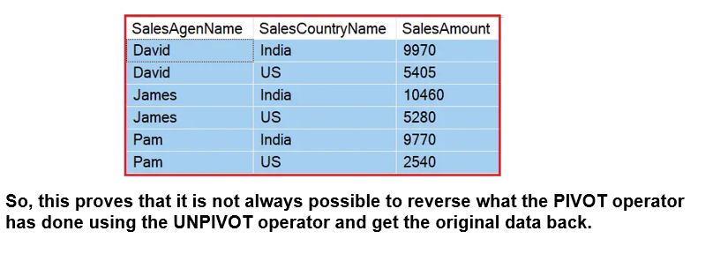

**How to schedule a job in SQL Server using SQL Server Agent**

